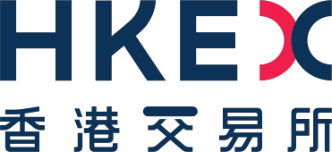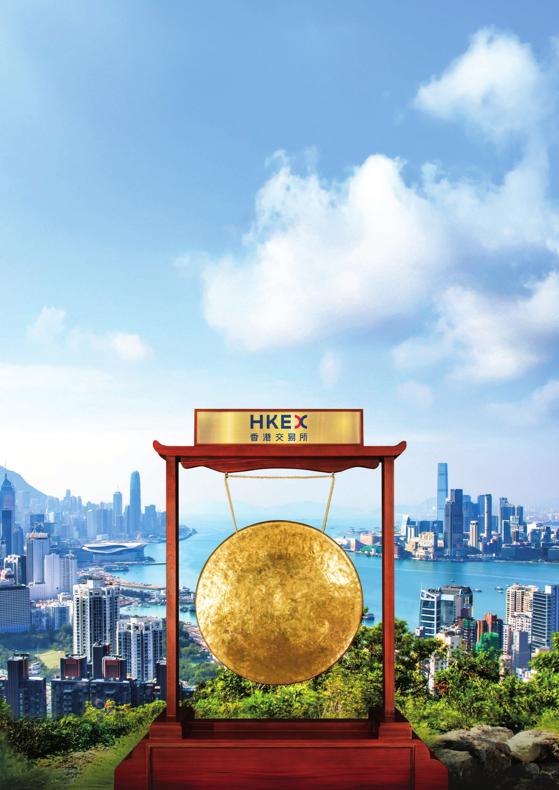

AnnualReport2025

25 Years Forward

Stock codes: 388 (HKD counter)and 80388 (RMB counter)

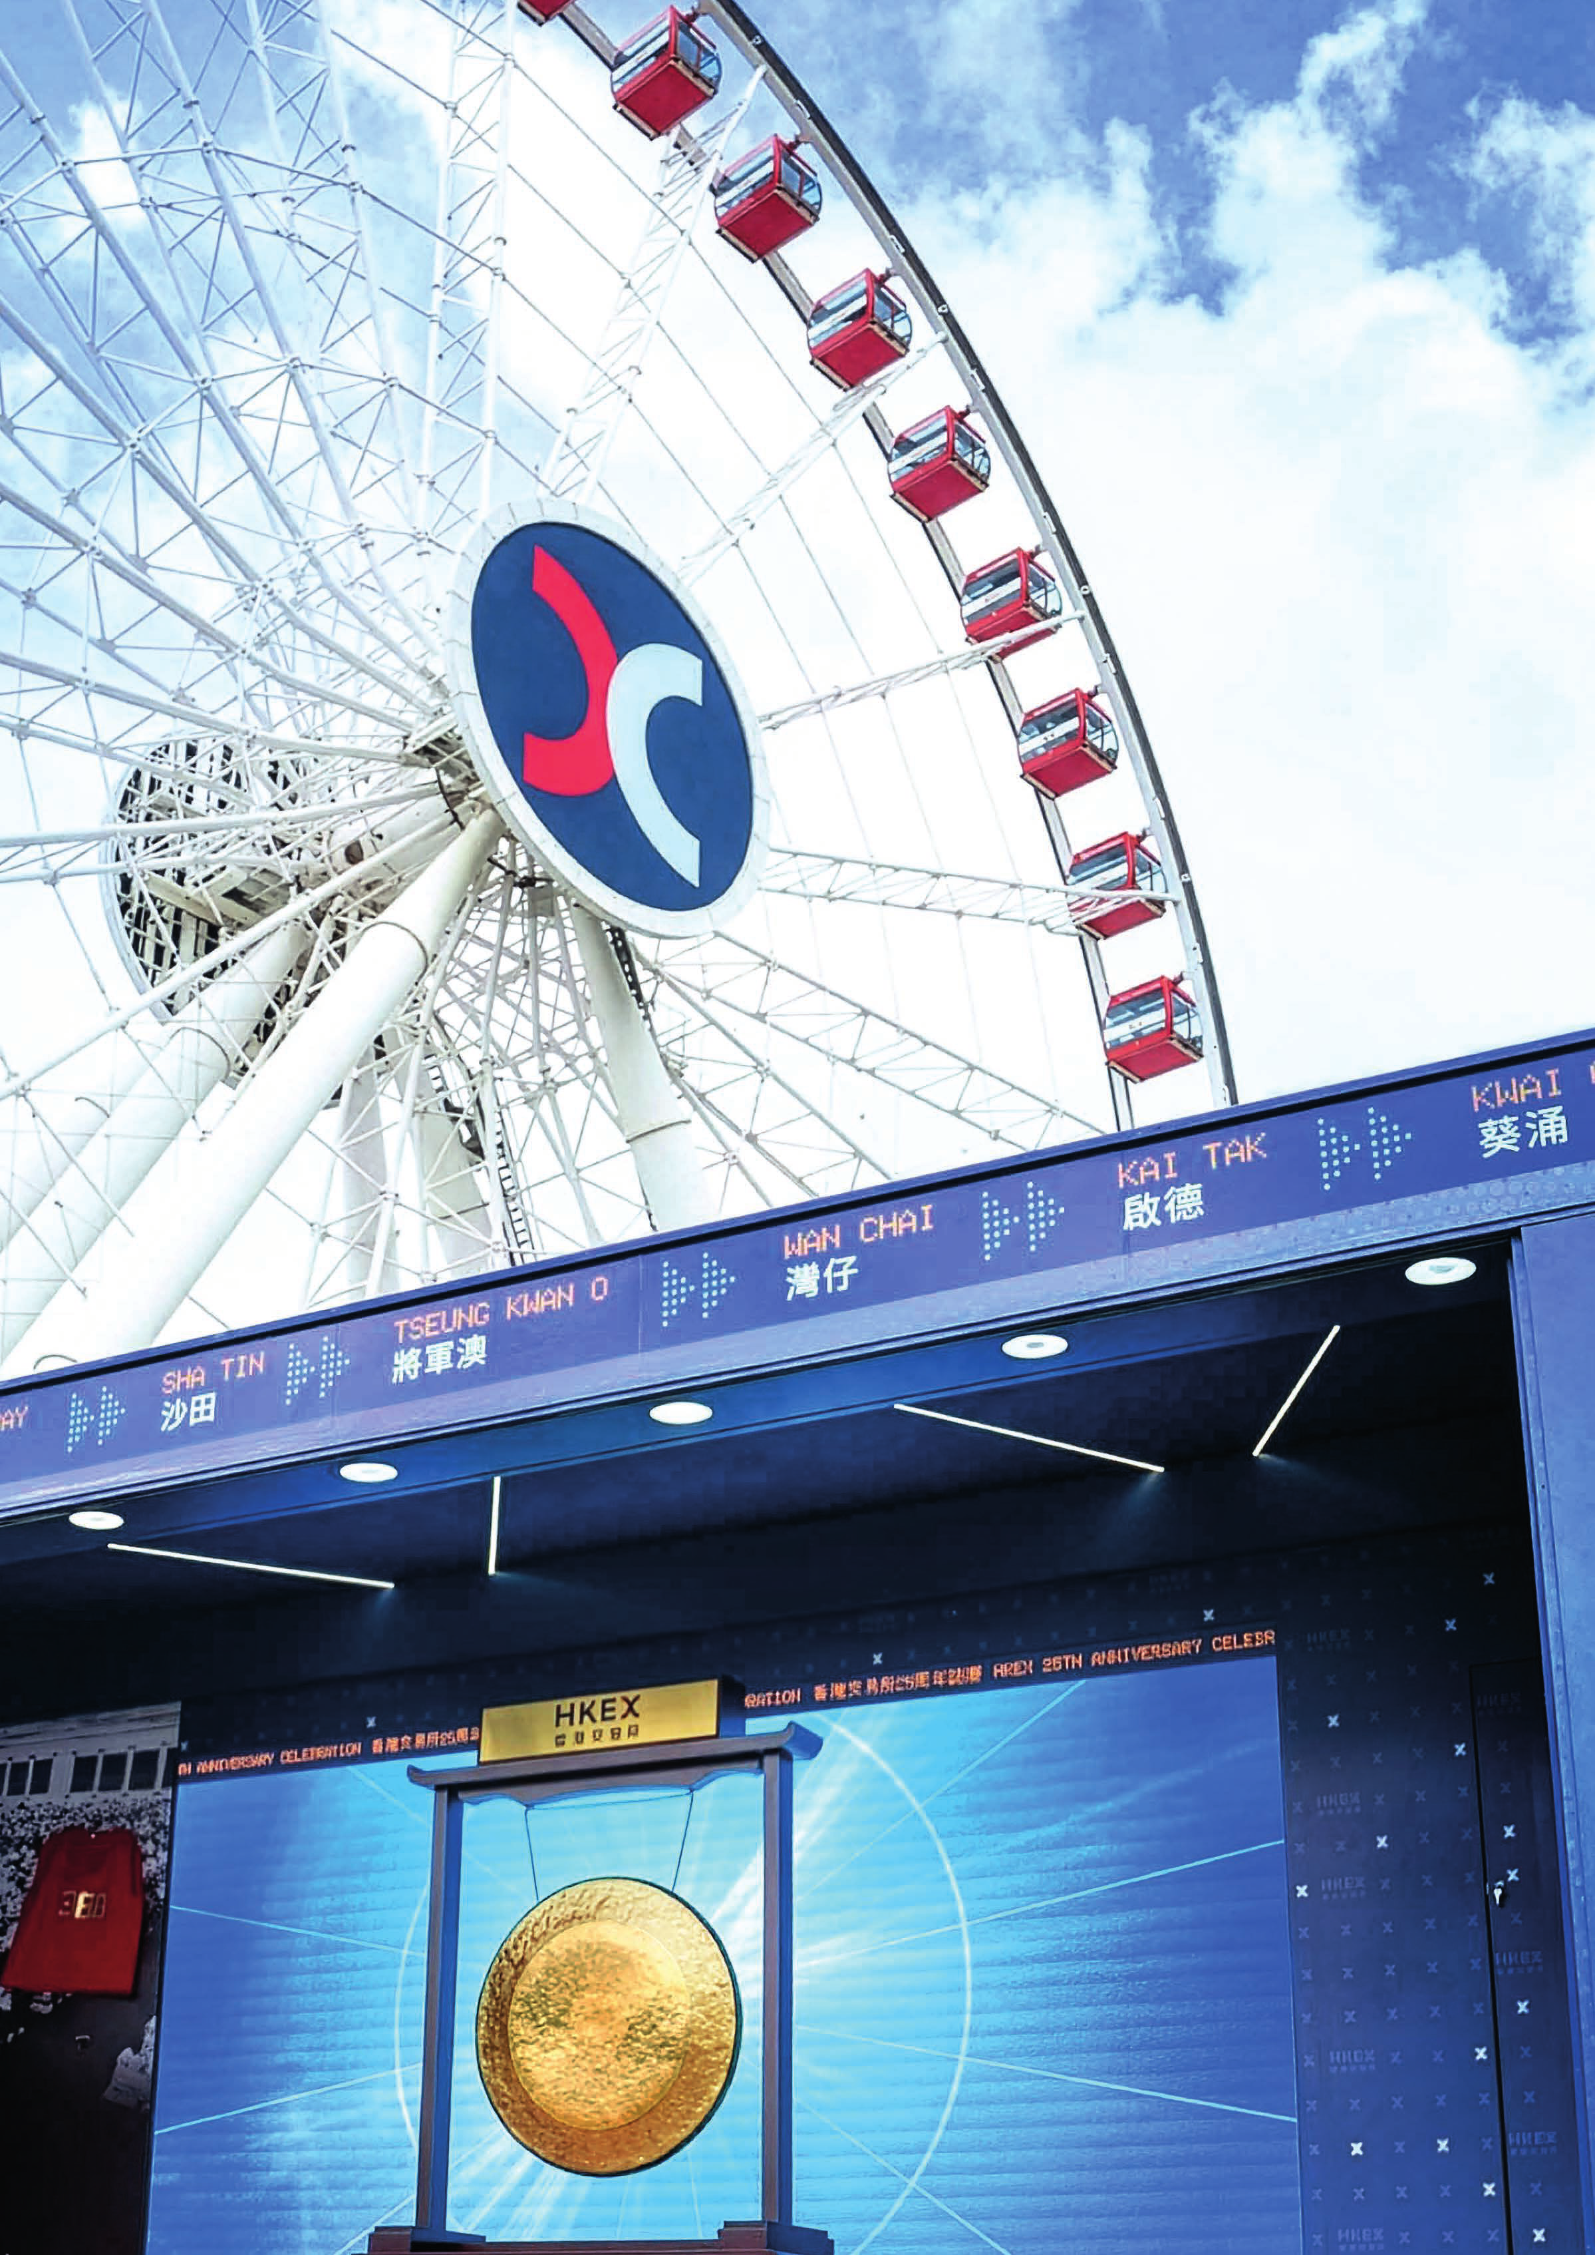

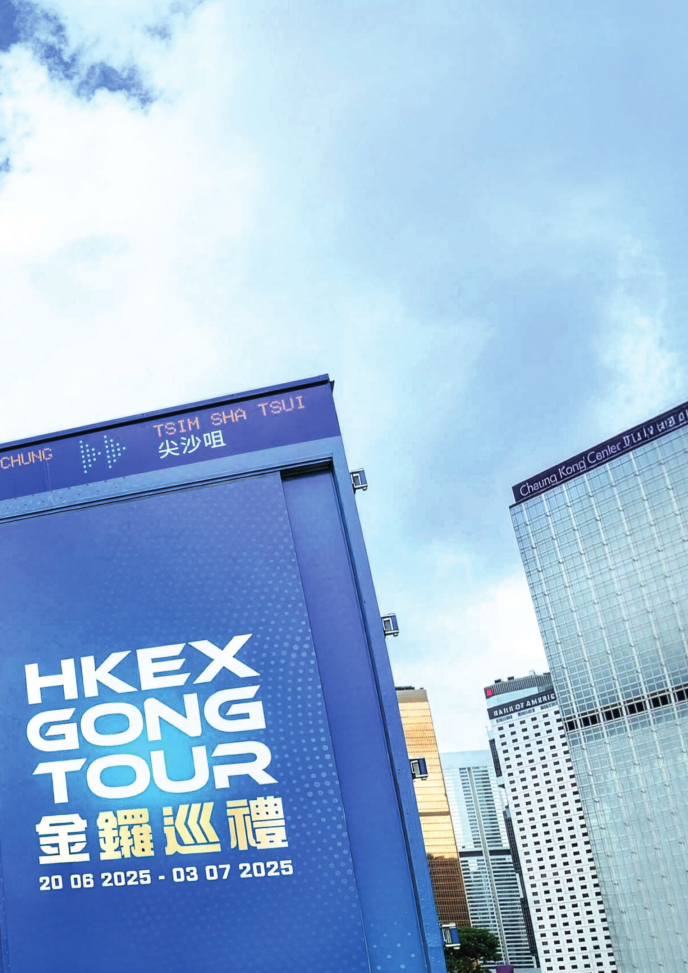
Contents
Overview
04 Strategic and Financial Highlights 15 Chairman’s Statement
19 Chief Executive Officer’s Review
Organisation
28 Board and Committees
30 Board of Directors and Senior Management 41 Management Committee
ManagementDiscussion and Analysis
44 Business Review 73 Financial Review
81 10-Year Financial Statistics
Governance
84 Corporate Governance Report
105 Nominationand Governance CommitteeReport 109 Audit CommitteeReport
112 Risk CommitteeReport
118 Remuneration CommitteeReport
127 Corporate Responsibility CommitteeReport 129 Directors’ Report
Financials
137 Auditor’s Report
141 Consolidated Income Statement
142 Consolidated Statementof Comprehensive Income 143 Consolidated Statementof Financial Position
144 Consolidated Statementof Changes in Equity 145 Consolidated Statementof Cash Flows
146 Notes to the Consolidated Financial Statements
Others
230 Shareholder Information 234 Glossary

Financial figures in this Annual Report are expressed in HKD unless otherwise stated

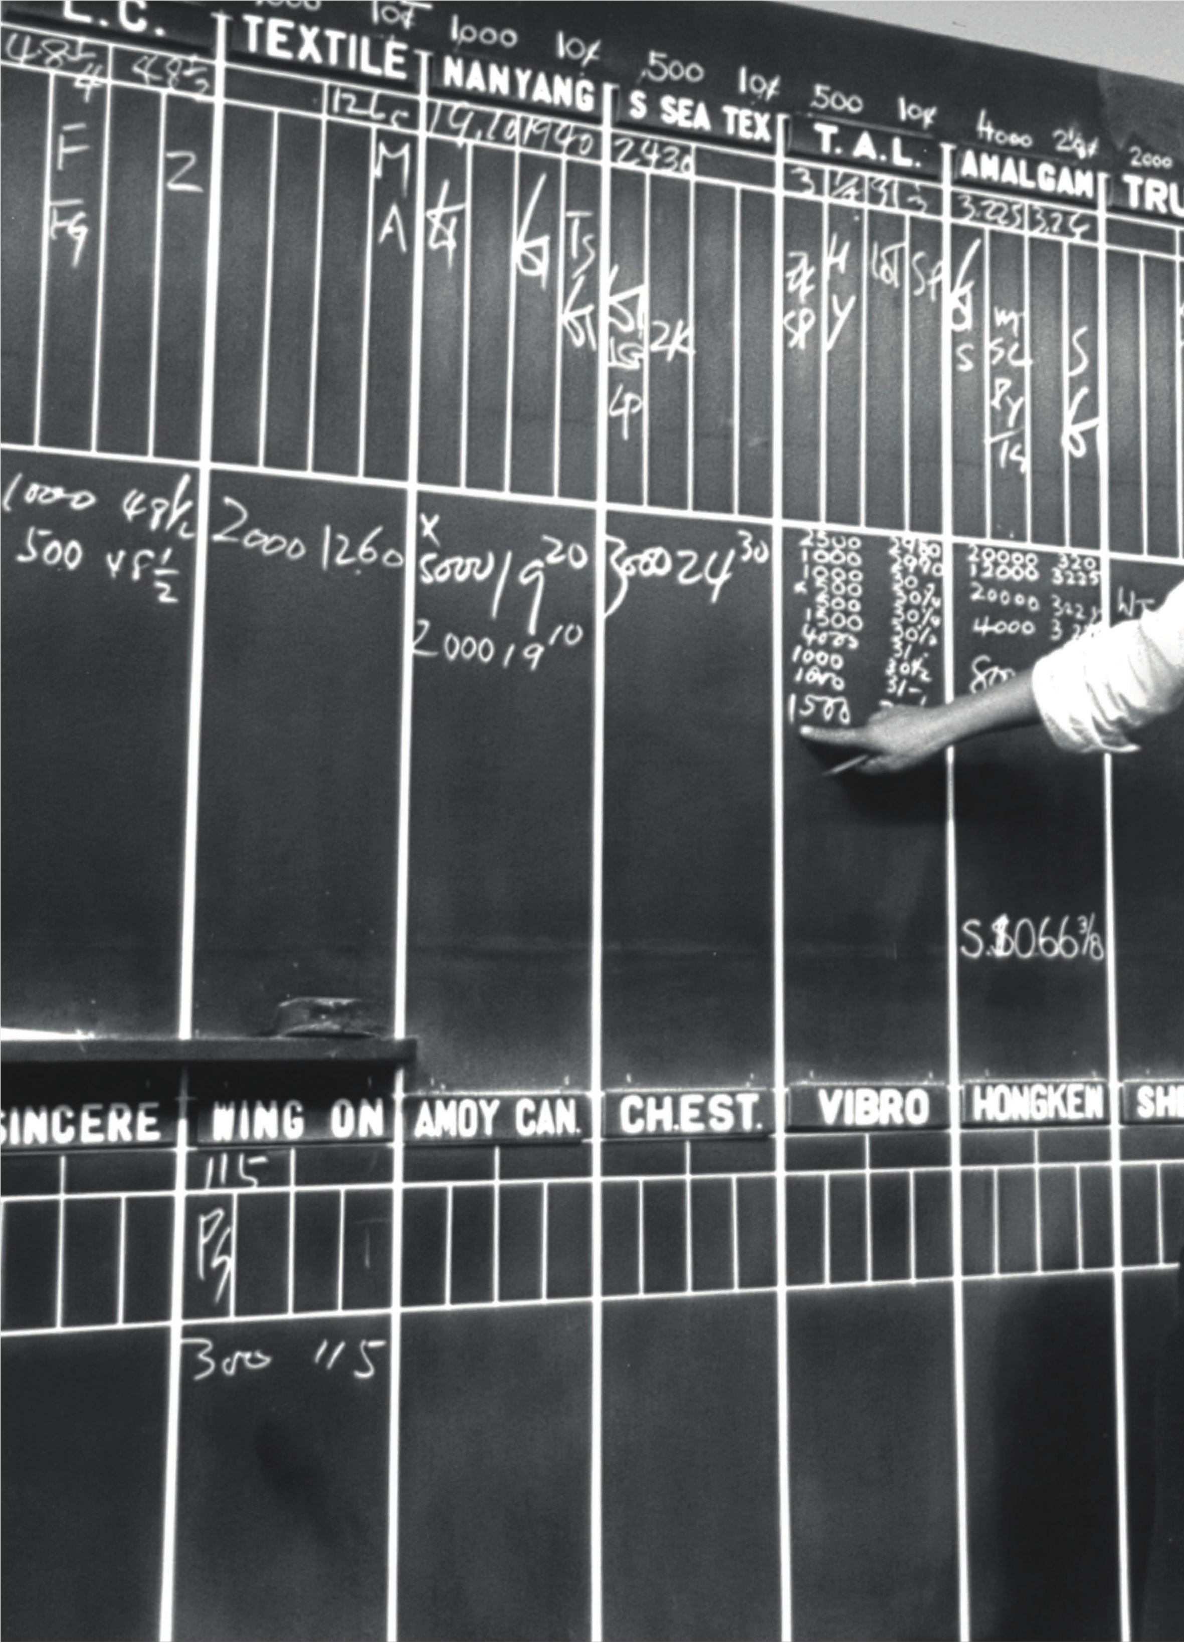
Overview

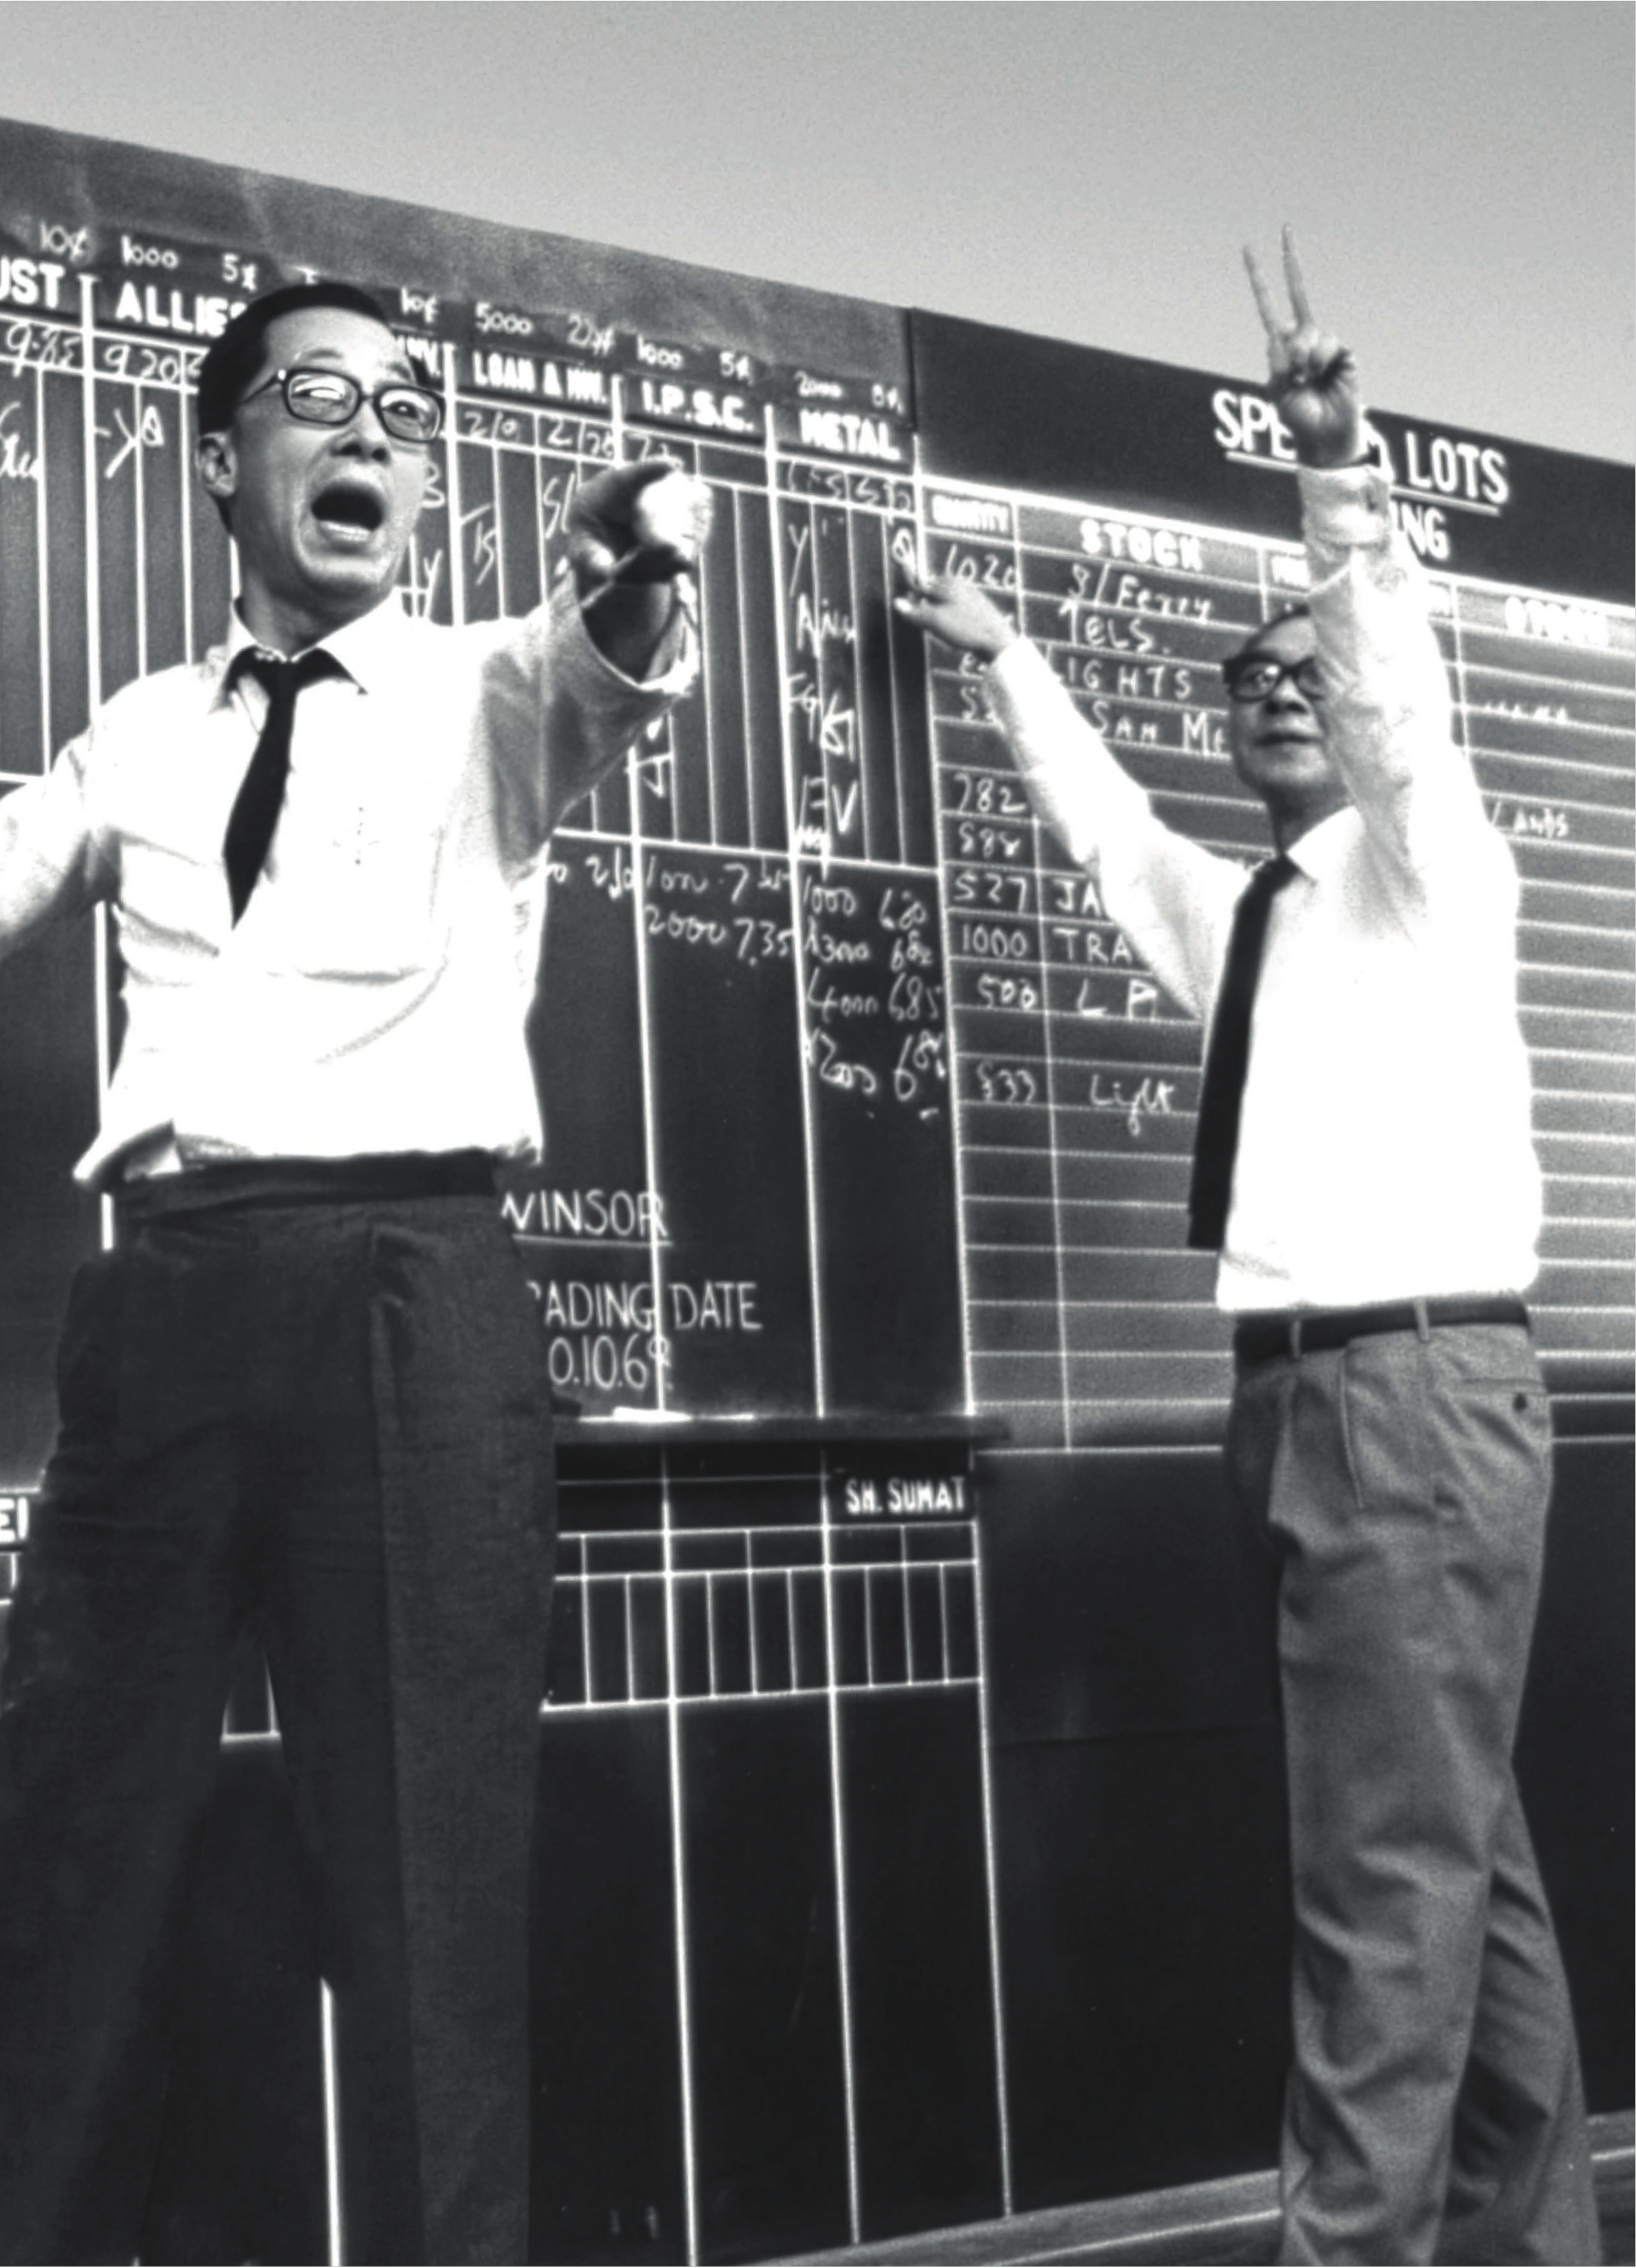

Strategic and Financial Highlights

In 2025, HKEX reinforced its role as a global superconnector, regained its position as the world’s leading venue for IPOs and set new trading as well as financial performancerecords. It was a
year of momentum,progress and transformationfor the Group, as ongoing reforms to our productecosystem and market microstructureensured we captured global investor trends, including the diversificationof global capital and the surge in Asian innovation.Even as our markets experienced very robust
performanceduring the year, we also maintained a strong pace of strategic delivery and continued to drive major reforms in our equities market, make strategic investments to expand our
multi-asset ecosystem, such as acquiring a 20 per cent stake in CMU OmniClear, facilitatethe launch of the firstLME-approved warehouses in Hong Kong, and expand into adjacent businesses.
While we expect volatilityto persist amid the prevailing macro landscape in 2026, we also see cause for optimismin capital markets as global investors adjust to the ongoing uncertaintyof an increasingly multipolarworld by seeking diversificationand risk managementopportunitiesin Asian, and specifically
Chinese, assets.
At HKEX, we believe our ongoing strategic development programme,which includes investments to modernise our critical infrastructure,will ensure our business continues to remain competitivein this global landscape and will supportHong Kong in its role as a global IFC, facilitatingcapital flows in Asia and between this region and the rest of the world. In 2026, we will continue to leverage our unique advantages, meet the evolving demands of global investors, and ensure our markets are accessible and competitive.
Bonnie Y Chan
Chief Executive Officer

04 HKEX Annual Report 2025



0505

Strategic and Operational Highlights

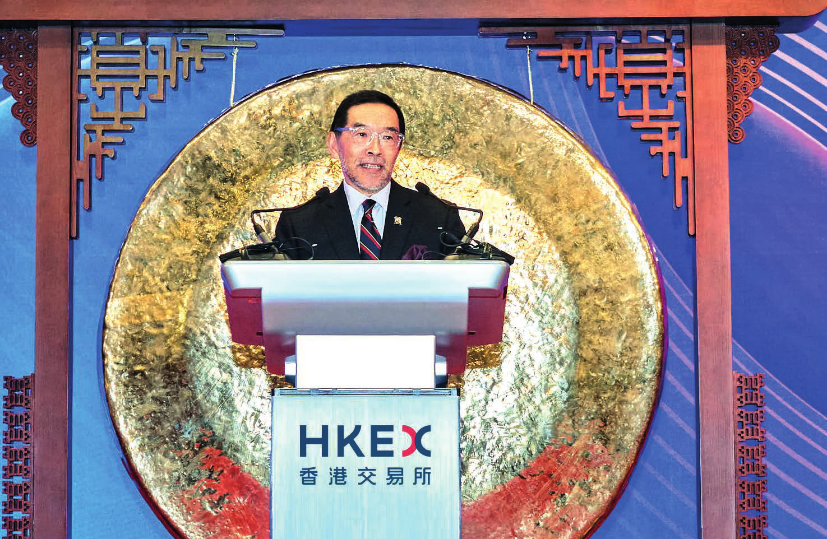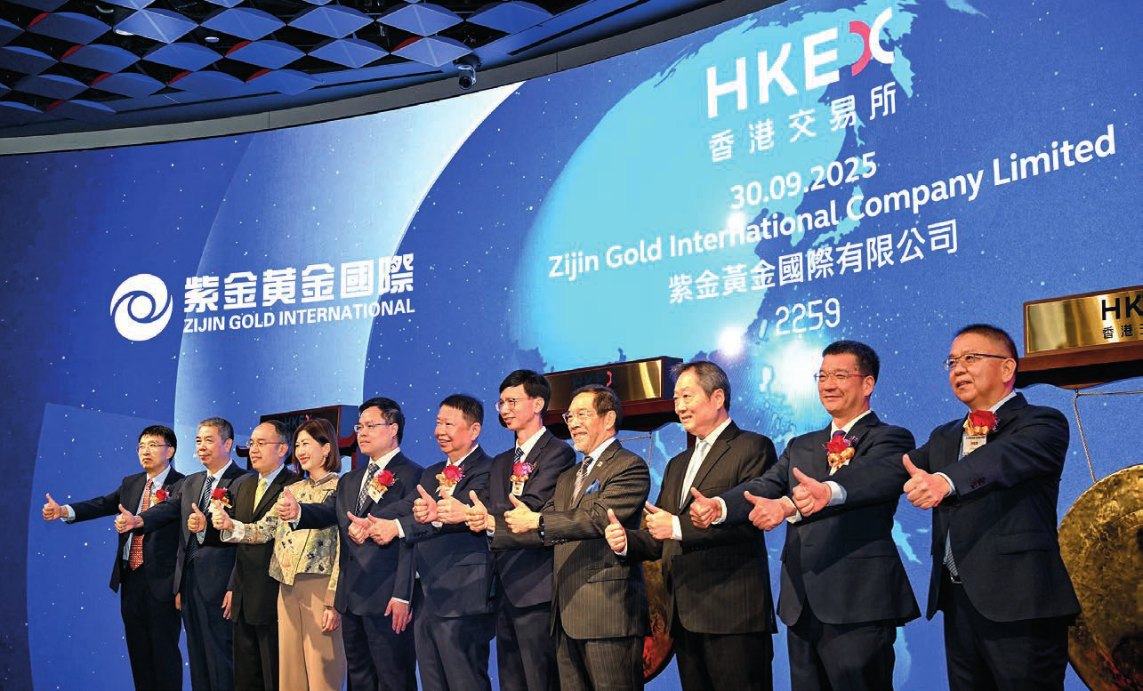

Corporate
24 Apr
Announced the purchase of permanentheadquarters premises
20 Jun
Launched the first-ever HKEX Gong Tour
27 Jun
25th anniversary of HKEX as a listed company
18 Sep
Signed MOU with Abu Dhabi Securities Exchange to explore joint initiatives
13 Oct
Announced the establishmentof a new subsidiary in Dubai, CommodityPricing and Analysis Limited, to operate as a commoditiespricing administrator
23 Dec
Completed acquisition of a 20 per cent stake in CMU OmniClear
Regulation
10 Mar
Added the Stock Exchange of Thailand as HKEX’s Recognised Stock Exchange
6 May
Jointly announced the launch of the Technology Enterprises Channel, and the introductionof a new confidentialfilingoption for specialist technology companies and biotech companies, with the SFC
4 Aug
New Listing Rule requirementson IPO price discovery and open market requirementstook effect
30 Sep
Published a consultationpaper on Review of Chapter 15A–StructuredProducts
17 Dec
Published consultation conclusions on Ongoing Public Float Requirements, with new requirementseffectivefrom 1 January 2026
Products and Services
26 Feb
Cross-listing of the world’s largest Nasdaq 100 ETF
21 Mar
OTC Clear accepted China Government Bonds and Policy Bank Bonds held throughBond Connect as margin collateralfor all derivative transactions
24 Mar
Asia’s firstSingle Stock L&I Products listed
28 May
First USD-denominated structuredproductlisted
28 May
The world’s firstL&I Product relatingto a single Korean stock listed
29 May
Asia’s firstSaudi Sukuk ETF listed
30 Jun
OTC Clear extended the maximumtenor of Northbound Swap Connect trades to 30 years
22 Sep
OTC Clear added 1-year Loan Prime Rate to the floating reference rate options under NorthboundSwap Connect
27 Oct
Asia’s firstSolana ETF listed
10 Nov
Expanded short‑-dated options with the addition of five new weekly stock options
28 Nov
Launched Hang Seng Biotech Index Futures
9 Dec
Launched HKEX Tech 100 Index
Market Operations
20 Jan
The LME approved Hong Kong as a new warehouse Delivery Point, which went live on 15 July 2025
29 Jan
The UK Supreme Court refused to give the appellants permission to appeal, leading to the conclusion of the judicial review of events in the nickel market in 2022
20 Mar
The LME reached a settlement agreement with the FCA regarding its enforcement investigationrelated to the nickel market events in 2022, drawing the investigationprocess to a close

06 HKEX Annual Report 2025

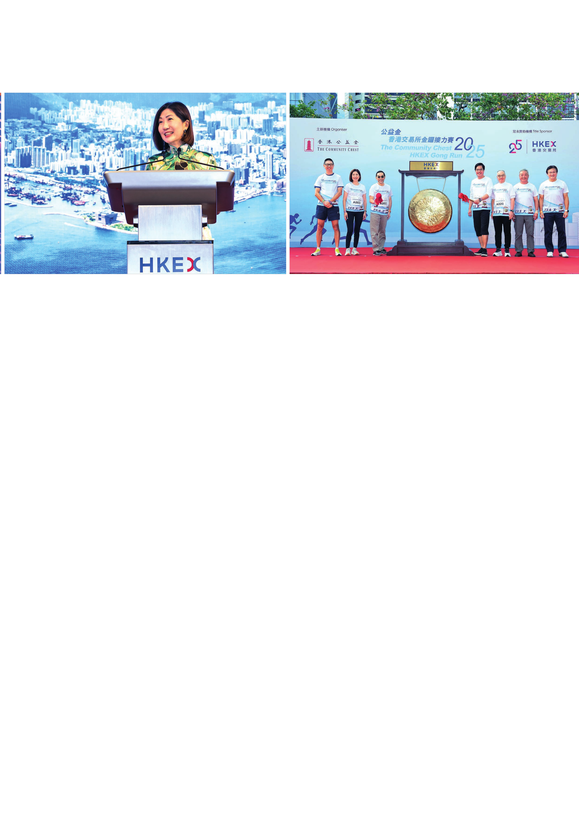

24 Mar
The LME launched new trading platform,LMEselect v10
1 Apr
The LME introduceddaily off-warrantstock reporting
16 Apr
Subsidiary legislation relatingto the implementationof UncertificatedSecurities Market was approved by the Legislative Council
30 Jun
Enhancement to the securities market stock settlementfee structuretook effect
30 Jun
Launched the Single Tranche MultipleCounter Settlement Model
2 Jul
Increased position limitsfor futures and options contracts referencing HSI, HSCEI and Hang Seng TECH Index
16 Jul
Published a discussion paper examining accelerated settlement for the Hong Kong Cash Market
4 Aug
ImplementedPhase 1 of the reductionof minimumspreads in the Hong Kong Securities Market
4 Aug
The LME launched Trade-at- Settlementcontractsfor certain metals
15 Aug
The LME published consultation outcomes confirmingthe introductionof block trade thresholds and an automated crossing solutionin Q1 2026
2 Oct
Enhancements to margin collateral arrangements across securities and derivatives clearing houses took effect
9 Oct
The LME published a roadmap outliningits proposed plan to modernise its options market
15 Oct
LME Clear introduced a triparty member margin collateral service with Euroclear Bank SA
8 Dec
OTC Clear announced revised margin collateral arrangements, with enhancements effective from 2 January 2026
18 Dec
Published a consultationpaper on Board Lot Framework Enhancements in the Hong Kong Securities Market
Sustainability
25 Mar
HKEX’s greenhouse gas emissions reductiontargets approved by the SBTi
15 Apr
Co-hosted the inaugural InternationalCarbon Markets Summitwith the SFC
30 Apr
Launched 2025 HKEX Impact Funding Scheme
18 Jun
Launched 2025 HKEX Charity Partnership Programme
20 Jun
Announced HKEX Foundation’s new flagship Care for Caregivers Programme
25 Jun
Co-hosted the International Dialogue on the Voluntary Carbon Market with China Beijing Green Exchange, National Centre for Climate Change Strategy and InternationalCooperation and China Emissions Trading Association
23 Sep
Signed MOU with Guangzhou Emissions Exchange, Shenzhen Green Exchange, Macao InternationalCarbon Emission Exchange to accelerate the green finance ecosystem development across the Greater Bay Area
13 Oct
The LME announced its roadmap to develop sustainable metal premium pricing for LME- approved brands
23 Nov
Hosted The CommunityChest HKEX Gong Run with The CommunityChest Hong Kong

Strategic and Financial Highlights 07

Financial Highlights

Annual Results
HKEX posted record revenue and other income and profitfor the second consecutive year in 2025.
Revenue and OtherIncome OperatingExpenses
+30% +5%

2025 revenue and other income was $29,161 million, 30 per cent higher than 2024:
• Core business revenue was up 32 per cent against 2024, attributableto increases in trading and clearing fees driven by record volumes across the Cash, Derivatives and Commodities Markets.
• Net investmentincome from Corporate Funds was $1,870 million,up 7 per cent compared with 2024, mainly due to non-recurringgains on valuation of the Group’s unlisted equity investments of $167 million(2024: losses of $62 million),partlyoffsetby lower net fair value gains of the External Portfolio(2025: $269 million; 2024: $447 million).
Operating expenses were 5 per cent higher than 2024. Excluding the $90 millionfine paid to the FCA in 2025, and a recovery of legal fees of $60 millionin 2024, both relatingto events in the nickel market in 2022, and charitable donations made by HKEX Foundation, operating expenses were up 2 per cent, attributableto higher staffand IT costs.

EBITDA1 ProfitAttributableto Shareholders
+40% +36%

EBITDA ¹ of $22,796 millionwas 40 per cent higher than 2024, with EBITDA margin ¹ at 79 per cent, 5 percentage points higher than 2024.
Profitattributableto shareholders was $17,754 million,36 per cent higher than 2024.

1 For the purposes of this Annual Report, EBITDA is defined as earnings before interest expenses and other finance costs, taxation, depreciation,amortisationand impairment.It excludes the Group’s share of results of the joint ventures and an associate. EBITDA margin is calculated based on EBITDA divided by revenue and other income less transaction-relatedexpenses. EBITDA and EBITDA margin are non-HKFRS measures used by managementfor monitoringbusiness performanceand may not be comparable to similar measures presented by other companies.

08 HKEX Annual Report 2025

