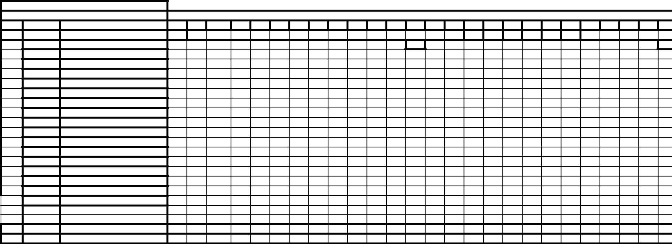
220
320
290
390
1460
329
479
1234
1250
680
679
400
510
1500
1391
VALUE
0
0
0
0
0
0
0
0
2
3
0
3
3
11
5
6
16
0
11
7
7
4
4
12
0
13
TOTAL QTY.
2
KAAF 100ML
19
AHL
18
1
1
SUMMER OUD
17
IGNITE OUD
16
1
2
1
1
1
1
ZELENY H/B 100ML
FGD01743
15
JOUD H/B 100ML
FGD01745
14
1
1
3
3
2
1
1
1
MEILLURE 80ML
FGD01711
13
1
1
GREEN PEARL 80ML
FGD01717
12
1
BINSHAIKH 90ML
FGD01263
11
3
1
4
2
1
4
4
MARJ 60ML
FGD01506
10
1
OUD LAVENDER 75ML NEW
FGD01116
9
1
1
1
1
1
1
OUD & ROSES 60ML
FGD01371
8
2
1
1
2
1
1
1
ROSE NOIR 75ML H/B
FGD01755
7
2
4
2
1
1
1
1
OUD COUTURE H/B 100ML NEW
FGD01741
6
1
2
1
1
COUTURE NOIR H/B 100ML NEW
FGD01742
5
2
2
1
3
BLUE BY AHMED H/B 100ML
FGD01744
4
1
2
1
1
1
1
BLUE OUD H/B 100ML
FGD01746
3
1
3
1
1
1
AZURE ROYAL H/B 100ML
FGD01747
2
1
2
3
HAYANAH/B 100ML
FGD01654
1
ITEM CODEITEM DESCRIPTION
SI.No
26
25
24
23
22
21
20
19
18
17
16
15
14
13
12
11
10
9
8
7
6
5
4
3
2
1
Apsara

PROMOTER:
STORELulu quis

