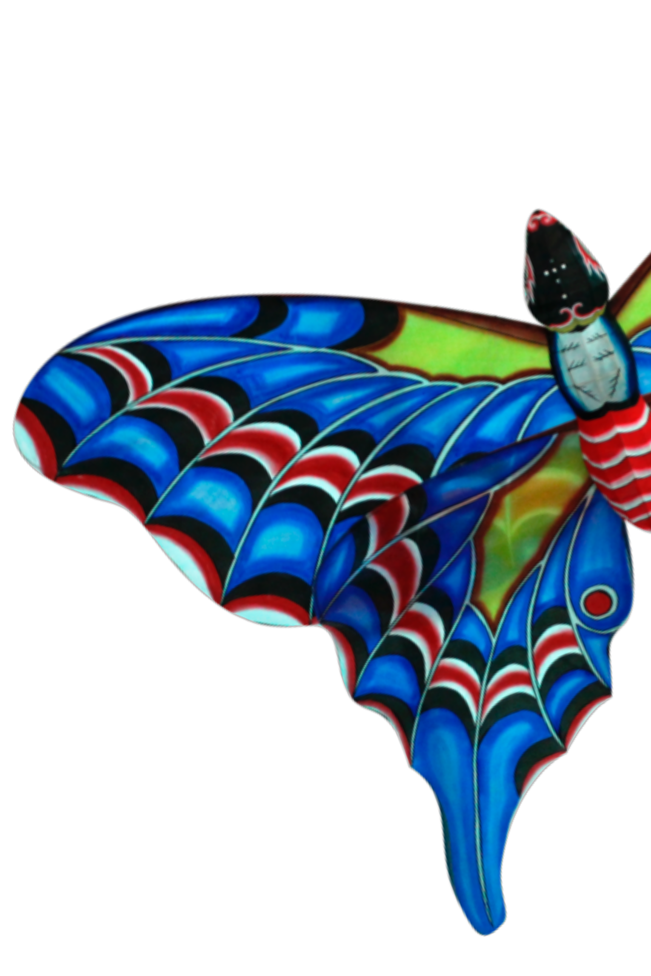Flights of Fancy

Creative types, spiritual seekers, and
originalthinkers throughout
history have felt the pull of the kite.

Benjamin Franklin demonstrated that lightning was an airborne electrical current by tying a metal key to his
favorite kite and setting it aloft during a powerful storm. New
Zealand’s Maori tribes believed that kites
shaped like birds could carry messages up to the ancestors, and in Thailand, kites were released into the sky
to appease the monsoon gods. Hindi speakers have come
up with over 100 words for“kite.”
Kite enthusiasts have an inherent appreciation for the spiritual and intellectual power of the kite. Standing in a grassy ﬁeld on a breezy day making smooth, balletic adjustments to the line, we feel connected to
both the earth and the sky. We are free to let our imaginations wander. At the same time, we maintain laserlike focus on keeping the kite aloft, keenly attuned to subtle shifts in the direction and force of the wind.
Flying a kite is a great way to alleviate stress. It forces the ﬂier to stay in the moment. Said another way, it helps the ﬂier step away from his or her desk, from email and voicemail and to-do lists, and spend a couple of hours outside on a beautiful day.

2 IKE NEWSLETTER



In modern-day culture, where one of the primary measures of status
and success is the number of obligations and meetings a person
packs into a single day,“goﬂya kite” is an insult. But it should be viewed instead as a generous invitation to
escape from the trap of busyness.
While there may be nothing “productive”
The kite is ﬂying, which represents the revelation or manifestation of the divine glory.
—Sri Chinmoy

about ﬂying a kite, there is much to be learned: the rules of aerodynamics, speciﬁc wind patterns, and the relative merits of
different line-handling mechanisms, from spools to reels.
Flying a kite with a child is a great way to spark his or her curiosity about ﬂight, about the weather, and most important,
about life’s bafﬂing ups and downs. “The optimist pleasantly ponders how high his kite willﬂy;the pessimist woefully wonders
how soon his kite will fall,” wrote scholar William Arthur Ward. Flying kites teaches us valuable skills for living a fulﬁlling life. Without a doubt, your kite will fall eventually. But you can always patch it up
and try again. And that, by its very deﬁnition, is resilience.
—Eden Sears, International Kite Enthusiasts member since 1998

Throw your dreams into space like a kite, and you do not know what it will bring back: a new life, a new friend, a new love, a new country.
—Anaïs Nin

IKENEWSLETTER 3

