
Nitro PDF Pro (for Mac) Installation Guide
Nitro Licensing System

Updated: September 2024

Nitro PDF Pro (for Mac) Installation Guide

Table of Contents
1 Introduction.................................................................................................................................................. 1
2 System Requirements................................................................................................................................. 1
3 Installing Nitro PDF Pro 14 (for macOS).................................................................................................... 1
3.1 Installing on Individual Workstations............................................................................................... 2
3.2 Installing Using MDM Solutions........................................................................................................ 2
3.3 Apple Device Management............................................................................................................... 3
3.4 Deploying Apps to Managed macOS Devices ................................................................................. 3
4 Activating Nitro PDF Pro (for Mac) ............................................................................................................. 4
4.1 Setting up the Nitro Team Account .................................................................................................. 4
4.2 Inviting Users & Assigning Licenses................................................................................................. 5
4.2.1 Inviting Users & Assigning Licenses Manually .......................................................................................................5
4.2.2 Managing Users & Licenses via Single Sign-On (SSO) ..........................................................................................7
5 Default Settings and Configurations.......................................................................................................... 9
5.1 Default Application ............................................................................................................................ 9
5.2 System Default Settings .................................................................................................................... 9
5.3 Disable Knowledge Assistant ......................................................................................................... 10
6 Updating Nitro PDF Pro for Mac ............................................................................................................... 11
6.1 In-App updater.................................................................................................................................. 11
6.2 Disable Updates by Default for Enterprise Deployments............................................................. 12
7 Contacting Nitro Support .......................................................................................................................... 12

Page | 3

Nitro PDF Pro (for Mac) Installation Guide

1 Introduction

This Installation Guide outlines best practices for deploying and activating Nitro PDF Pro for Mac on individual workstations, as well as across enterprise environments using a Mobile Device Management (MDM) solution such as Jamf Pro or similar platforms.
Please note that the information in this guide applies specifically to Nitro PDF Pro for Mac v14.x and later, and is specific to the Nitro Licensing System (NLS) licensing model.
This Installation Guide is designed for System and Application Administrators to assist in the efficient deployment and configuration of Nitro PDF Pro for Mac in an enterprise environment.

2 System Requirements
• macOS 12 (Monterey) or later
• Processor: Intel 64-bit, Apple M1 or later
• RAM: 1GB
• Available hard disk space: up to 2GB
•Display screen resolution: at least 1280x800 for a 13.3" laptop For a list of compatible devices, please refer to Apple Support.
Please check the Technical Requirements page for the latest Nitro PDF Pro (for Mac) system requirement updates.

3 Installing Nitro PDF Pro 14 (for macOS)

The Nitro PDF Pro for Mac binary is provided as a DMG package and can be downloaded from the following link: https://www.gonitro.com/installers/mac/v14/dmg/download.
This package supports both individual installation on workstations and deployment across multiple devices without user interaction. The deployment process for Nitro PDF Pro for Mac may vary depending on the Mobile Device Management (MDM) platform your organization uses.
For administrators, Nitro PDF Pro for Mac can be deployed using Apple Business Manager (ABM) or Apple School Manager (ASM). Simply add the MDM configuration to the ASM or ABM web portal to streamline the process.

Page | 1

Nitro PDF Pro (for Mac) Installation Guide

3.1 Installing on Individual Workstations
1. Download the Nitro PDF Pro (for Mac) installer.
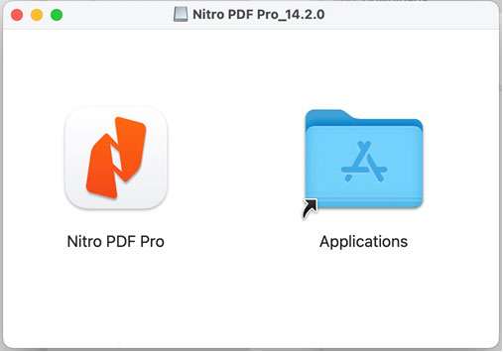2. Double-click the downloaded .dmg file to mount the installation disk. 3. Once mounted, a new window will open
displaying the Nitro PDF Pro application icon and a shortcut to your Applications folder.
4. Drag the Nitro PDF Pro application icon into the Applications folder to copy the software to your Mac’s hard drive.
5. After the copy is complete, Nitro PDF
Pro will be installed on your Mac.
6. Eject (unmount) the disk image by right- clicking it and selecting "Eject." You can then safely delete the .dmg file.
7. To begin using Nitro PDF Pro, open your Applications folder and launch the app.

3.2 Installing Using MDM Solutions
Nitro PDF Pro can be deployed with MDM solutions.
1. Download the Nitro PDF Pro (for Mac) installer.
2. Upload the .dmg installer to your MDM (Mobile Device
Management) solution.
3. In your MDM solution, create a new deployment profile for Nitro PDF Pro, ensuring it targets the appropriate devices or user groups.
4. Configure a script or policy within the MDM to copy the Nitro
PDF Pro application from the .dmg to the Applications folder. 5. Add a script in the deployment profile to eject (unmount) the
Note: Nitro PDF Pro for Mac does not automatically set itself as the default application for PDFs. For instructions on how to set Nitro PDF Pro
(for Mac) s the default PDF application, please refer to the Default Settings & Configurations section.

.dmg file once the installation is complete.
6. The MDM will confirm that Nitro PDF Pro has been successfully installed in the
Applications folder.
7. Optional: Configure the MDM to remove the .dmg file from the target devices
after installation to free up disk space.

Page | 2

Nitro PDF Pro (for Mac) Installation Guide

3.3 Apple Device Management

Organizations can streamline the deployment and management of Apple devices, as well as bulk app distribution, by utilizing Apple Business Manager (ABM) or Apple School Manager (ASM). These free services from Apple enable device supervision and automated Mobile Device Management (MDM) enrollments. When paired with an MDM solution, ABM and ASM simplify tasks such as account setup, policy application, app distribution, and setting restrictions.
While ABM and ASM can operate independently, their functionality is primarily limited to asset management. Apple designed these services to work in tandem with an MDM solution for optimal performance. Through Apple’s ABM/ASM services, organizations can manage:
• Devices enrolled under ABM/ASM
• Device model and serial number
• Purchased App Store apps
• App assignments
• Purchased content (applications, books, internal/special apps)
• App distribution
• Billing and payments
• Apple ID management

All Apple devices, including those running macOS, iOS, and iPadOS, come with built-in support for Mobile Device Management (MDM). MDM solutions allow organizations to securely and wirelessly configure and manage devices that they own or oversee. For streamlined management, it is highly recommended to use an MDM solution in conjunction with ABM or ASM.
Administrators can integrate multiple MDM platforms with ABM or ASM by adding the MDM configuration to the respective web portal.
For more information, you can find an overview of MDM for Apple devices here: Apple MDM Overview.

3.4 Deploying Apps to Managed macOS Devices
Administrators can use macOS Server or Apple Remote Desktop (ARD) to distribute Nitro PDF Pro to managed devices and users within an organization. For more details, explore the following resources:
• macOS Server Guide
• Apple Remote Desktop
• Distributing Apps Using Profile Manager or OS X Server

Page | 3

Nitro PDF Pro (for Mac) Installation Guide

4 Activating Nitro PDF Pro (for Mac)

Each Nitro PDF Pro user must have their own individual account and license. To activate Nitro PDF Pro, the Nitro Admin assigns licenses to specific users by name.

4.1 Setting up the Nitro Team Account
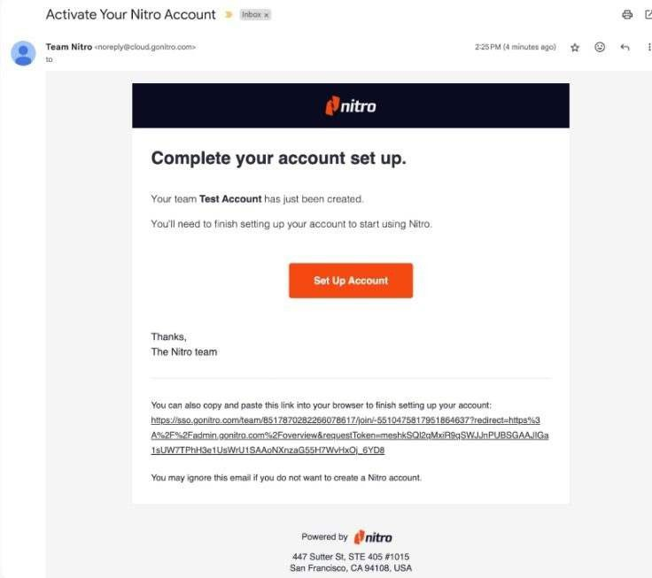The Nitro Admin must set up a Nitro Team Account for your organization before inviting users and assigning licenses.
1. Your designated Nitro Team Admin will receive an email with the subject “Activate Your Nitro Account”.
2. Upon receipt of the email, the Nitro
Admin should click the Set Up Account link in the email.

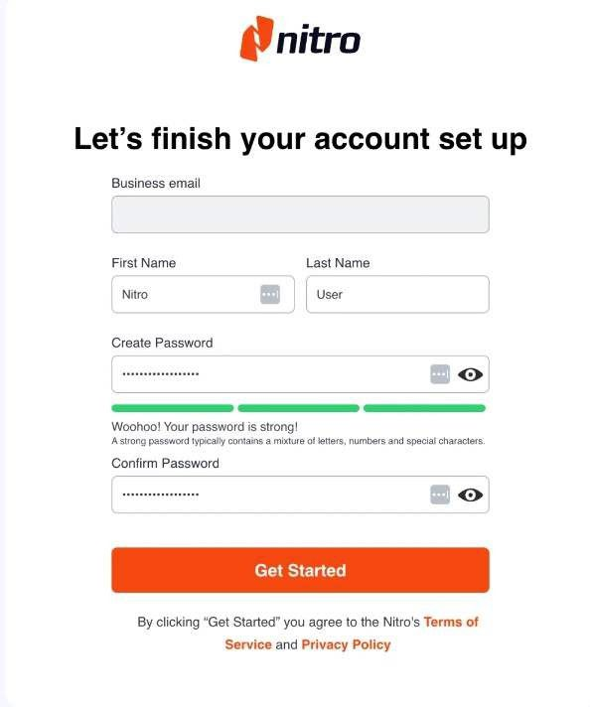

3. The Nitro Admin will be prompted to verify their name and email and create a password.
4. Click Get Started to complete the Nitro
Team Account creation process.

Page | 4

Nitro PDF Pro (for Mac) Installation Guide
4.2 Inviting Users & Assigning Licenses

As a Nitro Administrator, you can invite users to join the Nitro Team Account and assign licenses. There are two options for inviting users and assigning licenses:
1. Manual: Invite individual users (one at a time) or invite multiple users at the same time
by uploading a .CSV file.
2. Single Sign-On (SSO): Enable SSO to connect the Nitro Team Account to a SAML 2.0-based
authentication system such as Azure AD.

4.2.1 Inviting Users & Assigning Licenses Manually
1. Log in to the Nitro Admin Portal at https://admin.gonitro.com with the admin credentials you created in the previous step. The Nitro Admin Portal is a centralized system for managing named- user licenses for all Nitro products.
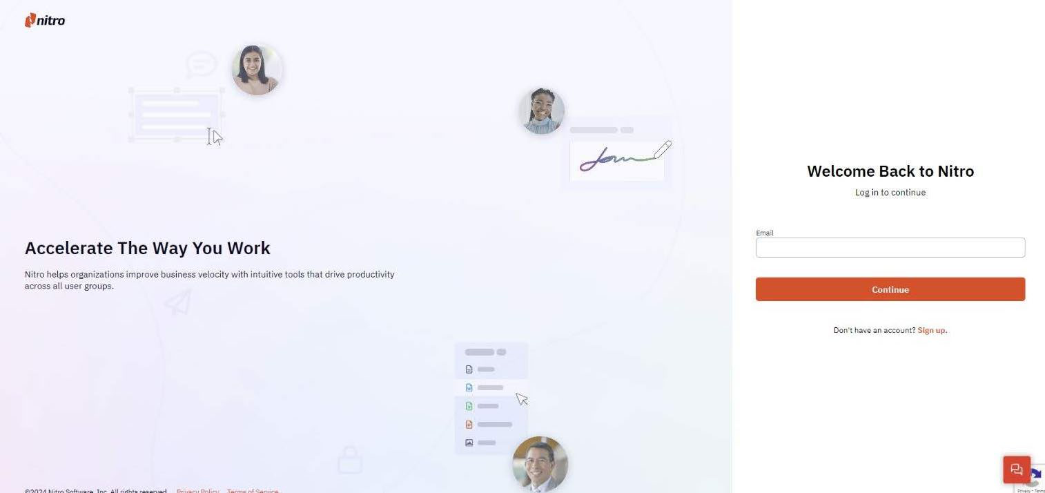

2. Select Users from the left-hand menu, then select Invite Users.

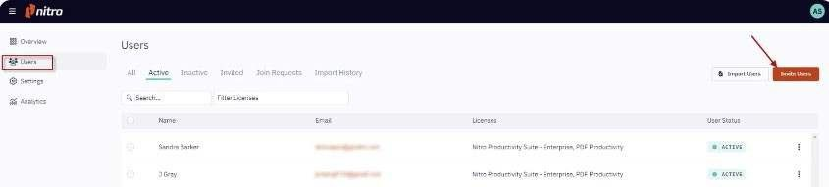

Page | 5

Nitro PDF Pro (for Mac) Installation Guide

3. Enter each user’s first name, last name, and email address. If you would like to invite multiple users at the same time, you can click on Inviting multiple users? and upload a .CSV file containing first name, last name, and email address of all users.
4. Optional: If you would like to assign Admin privileges to a user, select the appropriate Admin
Role:
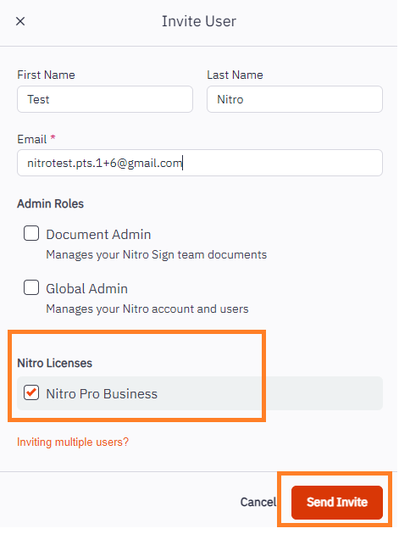•Document Admin: Ability to add Team documents and Team templates that can be accessed by all members of the Nitro Team.
•Global Admin: Ability to assign licenses and invite, suspend, and delete users from the Team Account.
5. Under Nitro Licenses, check the box for the license that you would like to assign. This will typically be Nitro Pro Business or Nitro Pro depending on the Nitro subscription type.
6. Click Send Invite to trigger an email to the user,
inviting them to activate their Nitro account.
7. Each invited user will receive an email asking them to activate their Nitro Account by verifying their name and email and creating a password.
8. Once the user activates their Nitro account, they will
appear under the Active tab in the Admin Portal.
For more information on inviting users and assigning licenses, please see the following video tutorial.

4.2.1.1 Accessing Nitro PDF
To use Nitro PDF Pro for the first time, users must supply their login credentials at the launch of the Nitro PDF Pro. Upon successful log in, Nitro PDF Pro will move out of Demo mode and users will have access to the full Nitro PDF Pro feature set.
If the user has activated Demo mode, they can manually login to their Nitro Account by clicking the Log In under the Nitro PDF Pro > Account. If the user continues with Demo mode, a Nitro watermark will be visible on any saved or printed documents.
For security reasons, users must launch Nitro PDF Pro (for Mac) with an active internet connection at least once every 30 days to maintain an active login. If more than 30 days have passed since the last connection, users will be prompted to re-authenticate when opening the application.

Page | 6

Nitro PDF Pro (for Mac) Installation Guide

4.2.2 Managing Users & Licenses via Single Sign-On (SSO)
Single Sign-on (SSO) allows your users to access Nitro products by authenticating through your Identify Provider (IdP). Nitro support SSO with any SAML-2.0 compliant IdP.

4.2.2.1 Verifying a Domain
Your account must have a verified domain to set up and enable SSO. Verifying your domain lets us confirm that you own that domain and can help you manage access to your account.
Step1:Addyourdomain
Your first domain will already be added for you and should appear in your list of domains. To add a new domain:
• Login to the Nitro Admin Portal.
• Select Settings in the left navigation pane and navigate to the Domains tab.
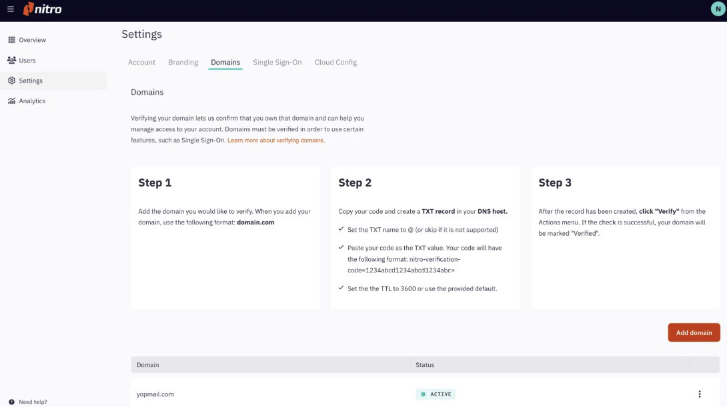

Step2:CreateaTXTrecordinyourDNShost
• Find your domain's code by selecting View Code from the Actions menu.
• Copy your code to the clipboard.
• Set record type to TXT
• Set the alias or host name to @ (or skip it if it is not supported)
• Paste your code as the TXT value. Your code will have the following format: nitro-
verification-code=1234abcd1234abcd1234abc=
• Set the TTL to 3600 or use the provided default
Step3:Verifyyourdomain
After creating the TXT record, select Verify from the Actions menu for the domain you would like to verify. If the check is successful, your domain will be marked "Verified".

Page | 7

Nitro PDF Pro (for Mac) Installation Guide

4.2.2.2 Setting up SAML SSO
1. Login to the Nitro Admin Portal.
2. Select Settings in the left navigation pane and navigate to the Single Sign-On tab. 3. Click the Set up SAML SSO button.

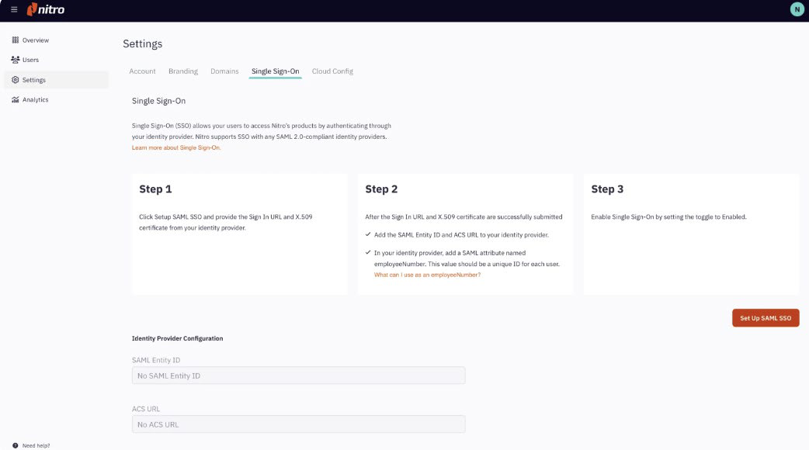

4. Enter your IdP's SignInURL and upload the x.509 Signing Certificate from your IdP. The x.509
Signing Certificate should be base 64 encoded and in a .ceror .pemformat.
5. When these have been submitted successfully, you will be provided with the SAMLEntity
ID and ACS URL. Add these to your IdP.
6. Nitro requires the SAML assertion to contain NameID, email, given_name, family_name and
employeeNumber of a user:
• NameID must be set to email address.
•employeeNumber can be any value that is unique for a user. E.g. for Okta: user.id. Note, if there is no obvious unique ID value, use email address instead.
• Please note the UI for adding custom attributes will vary depending on the
identity provider in use.
7. After completing the SAML SSO set up, check the box“Enable Single Sign-On”at the bottom of Single Sign-On tab. To disable SSO, uncheck this box. If SSO is disabled, users will need to log in with their Nitro Account email and password.

For additional information, please go to the Nitro User Guide.

Page | 8

