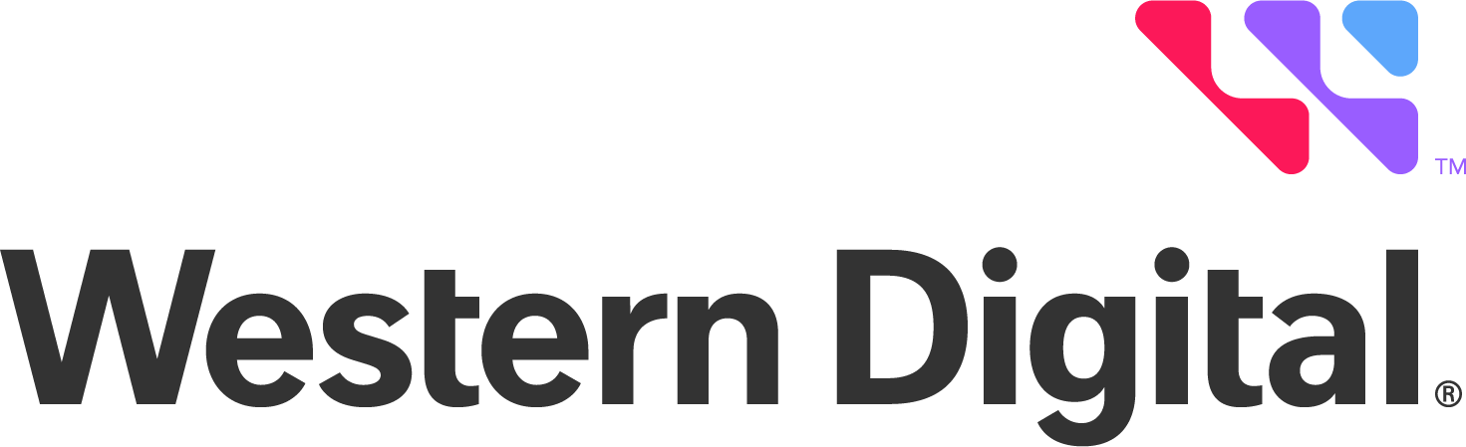Western Digital Corporation 5601 Great Oaks Parkway San Jose, California 95119
Tel: +1.408.717.6000

2023 Western Digital Trade Association Membership Dues and Lobbying Disclosures* Western Digital participates in trade associations globally. The following reflects organizations
in the United States to which Western Digital contributes $50,000 or more and the portion of that contribution has been identified as lobbying.

Trade Association (Calendar Year 2023) | 2023 Amount
Semiconductor Industry Association | $98,341.62
Silicon Valley Leadership Group | $22,500.00
U.S. Chamber of Commerce | $52,500.00
U.S. Chamber of Commerce China Center | $35,000.00
U.S. India Business Council | $17,500.00
* Does not include payments for sponsorships, events, or other initiatives.

©2024 Western Digital Corporation or its affiliates. All rights reserved.

