

Fkniih AYg[Ykbh Bk^]bmh DfbebYgh QDCD - TH@ DKHJH@ Q@L NHDRPM 4
NbYgh ]^`eb QihlmYf^gmb BYlY-JYohkh

_^ZZkYbh 2025

@ [nkY ]b
KhZbebmr KYgY`^k Fkniih AYg[Ykbh Bk^]bmh DfbebYgh


1. CTYWUMZ^QUTN
He ik^l^gm^ NQBJ v lmYmh k^]Ymmh [hg fhZbebmrNeYm_hkf, eY p^Z-Yiieb[Ymbhg i^k eY k^]Ysbhg^ ]^b NQBJ bg [heeYZhkYsbhg^ [hg Q[kYm lke.
Bhg J^``^ g. 77 ]^e 17 en`ebh 2020 v lmYmh [hgo^kmbmh be C^[k^mh-e^``^ g. 34 ]^e 19 fY``bh 2020 ([hlb]]^mmh |C^[k^mh PbeYg[bh}) [hg [nb lb _Y hZZeb`h Y mnmm^ e^ bfik^l^ ^ e^ inZZeb[a^ YffbgblmkYsbhgb [hg ibz ]b 100 ]bi^g]^gmb ]b Y]hmmYk^, ^gmkh be 31 ]b[^fZk^ ]b h`gb Yggh, ng NbYgh ]^`eb QihlmYf^gmb BYlY-JYohkh (NQBJ). J{hZZeb`h kb`nYk]Y e^ bfik^l^ ^ e^ inZZeb[a^ YffbgblmkYsbhgb nZb[Ym^ bg ng [Yihenh`h ]b P^`bhg^, bg ngY Bbmmu f^mkhihebmYgY, bg ng [Yihenh`h ]b Nkhobg[bY hiink^ bg ng Bhfng^ [hg ihiheYsbhg^ lni^kbhk^ Y 50.000 YZbmYgmb. J{hZb^mmboh ]b[abYkYmh Yee{Ykm. 229 v jn^eeh |]b _Yohkbk^ be ]^[hg`^lmbhgYf^gmh ]^e mkY__b[h g^ee^ Yk^^ nkZYg^ f^]bYgm^ eY kb]nsbhg^ ]^ee'nlh ]^e f^ssh ]b mkYlihkmh ikboYmh bg]bob]nYe^}.
He ln[[^llboh C^[k^mh 179 _bkfYmh [hg`bngmYf^gm^ be 12 fY``bh 2021 ]Ye Kbgblm^kh ]^eeY RkYglbsbhg^ D[heh`b[Y ^ ]Ye Kbgblm^kh ]^ee^ Hg_kYlmknmmnk^ ^ ]^eeY KhZbebmu Qhlm^gbZbeb, inZZeb[Ymh lneeY FS ]^e 26 fY``bh 2021, ]^_bgbl[^ e^ fh]Yebmu YmmnYmbo^ ]b jnYgmh ik^oblmh ]Ye [bmYmh Ykm. 229 ]^e CJ 34/2020. Qhgh 9 `eb Ykmb[heb ]b mYe^ ]^[k^mh, be ikbfh ]^b jnYeb, |M``^mmh ^ _bgYebmu}, k^[bmY [a^ eh lm^llh ]^[k^mh v |~ _bgYebssYmh Y [hgl^gmbk^ eY kb]nsbhg^ lmknmmnkYe^ ^ i^kfYg^gm^ ]^ee{bfiYmmh YfZb^gmYe^ ]^kboYgm^ ]Ye mkY__b[h o^b[heYk^ ikboYmh g^ee^ Yk^^ nkZYg^ ^ f^mkhihebmYg^, ikhfnho^g]h eY k^YebssYsbhg^ ]b bgm^ko^gmb ]b hk`YgbssYsbhg^ ^ `^lmbhg^ ]^eeY ]hfYg]Y ]b fhZbebmu ]^ee^ i^klhg^ [a^ [hgl^gmYgh eY kb]nsbhg^ ]^ee{nlh ]^e o^b[heh ikboYmh bg]bob]nYe^ Y fhmhk^ g^`eb lihlmYf^gmb lblm^fYmb[b [YlY-eYohkh ^ _Yohkbl[Ygh be ]^[hg`^lmbhgYf^gmh ]^e mkY__b[h o^b[heYk^}.
Qb l^`gYeY [a^, l^ be C^[k^mh 179 li^[b_b[Y [a^ |@e _bg^ ]^eeY o^kb_b[Y ]^eeY lh`ebY ]^b 100 ]bi^g]^gmb bg h`gb lbg`heY ngbmu eh[Ye^ ~ lb [hglb]^kYgh [hf^ ]bi^g]^gmb e^ i^klhg^ [a^, l^iink ]bi^g]^gmb ]b Yemk^ bfik^l^ ^ inZZeb[a^ YffbgblmkYsbhgb, hi^kYgh lmYZbef^gm^, hoo^kh [hg ik^l^gsY jnhmb]bYgY [hgmbgnYmboY, ik^llh eY f^]^lbfY ngbmu eh[Ye^ bg obkmn{ ]b [hgmkYmmb ]b YiiYemh ]b l^kobsb h ]b _hkf^ jnYeb ]blmY[[h, [hfYg]h h Yemkh}, be ln[[^llboh C^[k^mh ]^e 16 l^mm^fZk^ 2022 ]^e Kbgblm^kh ]^eeY RkYglbsbhg^ D[heh`b[Y Y``bng`^ [a^ |Hg [Ylh ]b lh[b^mu bg_kY`kniih nZb[Ym^ g^eeY lm^llY ngbmu eh[Ye^, eY lh`ebY ]^b 100 ]bi^g]^gmb v [Ye[heYmY lhffYg]h b ]bi^g]^gmb ]^ee^ ]bo^kl^ lh[b^mu ]^e kY``kniiYf^gmh}.
MZb^mmboh ]^e NbYgh v _hkgbk^ fblnk^ Yem^kgYmbo^ ^ ibz [hgo^gb^gmb kbli^mmh Yee{nlh ]^ee{YnmhfhZbe^ YmmkYo^klh ng bglb^f^ hmmbfYe^ ]b Ysbhgb nmbeb i^k eY kYsbhgYebssYsbhg^ ]^`eb lihlmYf^gmb [YlY-eYohkh ]^b ]bi^g]^gmb, [a^ bg[en]Y l^kobsb ^ Ymmbobmu ]b KhZbebmr KYgY`^f^gm. Bhlx [hg[^ibmh, be NbYgh v bg `kY]h ]b ]^m^kfbgYk^, [hlx [hf^ li^[b_b[Ymh Yee{@km. 3 ]^e [bmYmh CK ]^e 12 fY``bh 2021, |~ oYgmY``b lbY i^k b ]bi^g]^gmb [hbgohemb, bg m^kfbgb ]b m^fib ]b lihlmYf^gmh, [hlmb ]b mkYlihkmh ^ [hf_hkm ]b mkYlihkmh, lbY i^k e{bfik^lY h eY inZZeb[Y YffbgblmkYsbhg^ [a^ eh Y]hmmY, bg m^kfbgb ^[hghfb[b ^ ]b ikh]nmmbobmu, ghg[aw i^k eY [hee^mmbobmu, bg m^kfbgb YfZb^gmYeb, lh[bYeb ^] ^[hghfb[b}.
Bhf^ ik^oblmh ]Yee{@km. 3 ]^e [bmYmh CK ]^e 12 fY``bh 2021, [hg ]^[k^mh ]bk^mmhkbYe^ ]^e Kbgblm^kh ]^eeY RkYglbsbhg^ D[heh`b[Y ^ ]^e Kbgblm^kh ]^ee^ Hg_kYlmknmmnk^ ^ ]^eeY KhZbebmu Qhlm^gbZbeb lhgh lmYm^ Y]hmmYm^ be 4 Y`hlmh 2021 e^ |Jbg^^ `nb]Y i^k eY k^]Ysbhg^ ^ e{bfie^f^gmYsbhg^ ]^b ibYgb ]^`eb lihlmYf^gmb [YlY-eYohkh (NQBJ)}, Y [nb _Y kb_^kbf^gmh be ik^l^gm^ ]h[nf^gmh, l^[hg]h e^ jnYeb e{hZb^mmboh ]b ng NQBJ |~ v [hgl^gmbk^ eY kb]nsbhg^ lmknmmnkYe^ ^ i^kfYg^gm^ ]^ee{bfiYmmh YfZb^gmYe^ ]^e mkY__b[h o^b[heYk^ ikhfnho^g]h eY k^YebssYsbhg^ ]b bgm^ko^gmb ]b hk`YgbssYsbhg^ ^ `^lmbhg^ ]^eeY ]hfYg]Y ]b fhZbebmu ]^ee^ i^klhg^}.


2. FJWYN QTOUWSJYQ[J N MQ JTJRQXQ
2.1. @TJRQXQ MNRRN LUTMQ^QUTQ XYWZYYZWJRQ MNRR`J^QNTMJ
JY l[^emY ]^eeY fh]Yebmu ]b mkYlihkmh i^k `eb lihlmYf^gmb [YlY-eYohkh iny ^ll^k^ ]^m^kfbgYmY ]Y ibz _Ymmhkb, ]b gYmnkY bgm^kgY Yee{Ysb^g]Y h k^eYmbob Ye [hgm^lmh ^lm^kgh. He ik^l^gm^ iYkY`kY_h ]^l[kbo^ e^ [hg]bsbhgb lmknmmnkYeb ]^ee{Ysb^g]Y, oYe^ Y ]bk^ e^ [YkYmm^kblmb[a^ bgm^kg^ [a^ bg_en^gsYgh eY l[^emY fh]Ye^ ]b lihlmYf^gmh ]Y iYkm^ ]^b eYohkYmhkb. Qb kbihkmYgh lbgm^mb[Yf^gm^ e^ ikbg[biYeb [YkYmm^kblmb[a^ ]^eeY l^]^, kbe^oYgmb Yb _bgb ]^eeY ]^_bgbsbhg^ ]^e `kY]h ]b Y[[^llbZbebmu, kY[[hem^ f^]bYgm^ eY [hfibeYsbhg^ ]b ngY |Q[a^]Y bg_hkfYmboY ln [hg]bsbhgb lmknmmnkYeb Ysb^g]Yeb ^ h__^kmY ]b mkYlihkmh} [h^k^gm^ [hg e{@ee^`Ymh 2 ]^ee^ |Jbg^^ `nb]Y i^k eY k^]Ysbhg^ ^ e{bfie^f^gmYsbhg^ ]^b ibYgb ]^`eb lihlmYf^gmb [YlY-eYohkh}.

DULJRQ^^J^QUTN

HWMO | HKTWYO
Jh[YebssYsbhg^ ]^eeY l^]^ | SkZYgY [^gmkYe^
C^ghfbgYsbhg^ ]^eeY l^]^ | QDCD - TH@ DKHJH@ Q@L NHDRPM 4
Bhfng^ | P^``bh DfbebY
B@N | 42124
Hg]bkbssh ^ gnf^kh [bob[h | TH@ DKHJH@ Q@L NHDRPM 4
FNWXUTJRN MQVNTMNTYN

HWMO | HKTWYO
Lnf^kh mhmYe^ ]b ]bi^g]^gmb | 810
Lnf^kh i^klhgYe^ ]bi^g]^gm^ m^fih ib^gh | 772
Lnf^kh i^klhgYe^ ]bi^g]^gm^ iYkm mbf^ | 38
Lnf^kh i^klhgYe^ ^lm^kgh | 0
IQVURUPQN RJ[UWJYUWQ

HWMO | HKTWYO
Cbkb`^gmb | 0.00%
OnY]kb | 0.00%
Hfib^`Ymb | 0.00%
Mi^kYb | 0.00%
EWJWQU MQ RJ[UWU

HWMO | HKTWYO
MkYkbh ]b bg`k^llh ]^b ]bi^g]^gmb | 08:15 - 14:30
MkYkbh ]b nl[bmY ]^b ]bi^g]^gmb | 13:30 - 16:45
@emkb hkYkb
Bhf^ o^g`hgh `^lmbm^ e^ hk^ lmkYhk]bgYkb^? | Nhllhgh ^ll^k^ k^[ni^kYm^ (^l.: AYg[Y hk^)
QYZYmh eYohkYmboh | Lh
Chf^gb[Y eYohkYmboY | Lh
GQXUWXN, XNW[Q^Q N MUYJ^QUTQ J^QNTMJRQ
CKROQRI PIQ LE JIRSKONI HILLE MOFKLKSW HIK HKPINHINSK
HWMO | HKTWYO
An]`^m YggnYe^ ]^]b[Ymh YeeY `^lmbhg^ ]^eeY fhZbebmu ]^b | 0,00
]bi^g]^gmbW•X
Pblhkl^ nfYg^ ]^]b[Ym^ YeeY `^lmbhg^ ]^eeY fhZbebmu ]^b | 0,00
]bi^g]^gmb Wgt i^klhg^X

DIQUKVK HK SQERPOQSO PIQ K HKPINHINSK

ANGINSKUK / FTONK MOFKLKSW PIQ K HKPINHINSK
HWMO | HKTWYO | DW[O
LYo^mmY Ysb^g]Ye^ | Lh
@nmhfhZbeb Ysb^g]Yeb | Qx | ]n^ Ynmh Y] nlh l^kobsbh
Khmh/Zb[b[e^mm^/fhghiYmmbgb Ysb^g]Yeb | Lh
BYk laYkbg` Ysb^g]Ye^ | Lh
NbYmmY_hkfY ]b [Yk ihhebg` | Lh

@QII HK RORSE QKRIQUESI EK HKPINHINSK
HWMO | HKTWYO | DW[O
Hg[^gmbob/l[hgmb i^k be mkYlihkmh inZZeb[h | Lh
Hg[^gmbob/l[hgmb i^k l^kobsb ]b fhZbebmu [hg]boblY | Lh
Hg[^gmbob Yee{nlh ]^eeY Zb[b[e^mmY (Zbd^ mh phkd) | Lh
Hg[^gmbob/l[hgmb i^k [ab _Y [Yk ihhebg` | Lh

@LSQO
HWMO | HKTWYO | D]UOYW | DW[O
Nhlmb Ynmh | Lh | 0
Nhlmb fhmh | Lh | 0
Nhlmb Zb[b | Lh | 0
Rbiheh`bY ihlmb Zb[b
Nhlmb Ynmh [Yk ihhebg` | Lh | 0
C^ihlbmh fhghiYmmbgb | Lh
Nk^l^gsY ]b ingmb ]b kb[Ykb[Y i^k Zb[b ^/h fhghiYmmbgb | Lh
HWMO | HKTWYO | DW[O
QfYkm phkdbg`/m^e^eYohkh | Qx
Ebgh Y jnYgm^ hk^/f^ss^ `bhkgYm^/`bhkgYm^/i^k[^gmnYeb ]b hkYkbh ihllhgh ^ll^k^ lohem^ bg fh]Yebmu lfYkm phkdbg`? | 13
OnYeb lhgh b k^jnblbmb i^k [nb ihllY ^ll^k^ lohemY e'Ymmbobmu eYohkYmboY bg fh]Yebmu lfYkm? | Jh QfYkm Uhkdbg` iny ^ll^k^ kb[ab^lmh ]Y mnmm^ e^ i^klhg^ [a^ kb[hikhgh knheb  [hfiYmbZbeb [hg jn^lmY fh]Yebmu ]b eYohkh
T^g`hgh _hkgbmb bg ]hmYsbhg^ `eb lmknf^gmb i^k lohe`^k^ eh lfYkm phkdbg`? (i[, m^e^_hgh,^[[.) | Qx
Qih`ebYmhb ^ ]h[[^ | Lh
K^glY Ysb^g]Ye^ | Lh
@lbeh Ysb^g]Ye^ | Lh
@emkb l^kobsb | Lh

HYWZSNTYQ MQ LUSZTQLJ^QUTN
HWMO | HKTWYO
TheYgmbgb ^/h Zkh[ank^ | Lh
@__bllbhgb bg liYsb (Y] ^l. eh[Yg]bg^ bg ZY[a^[a^) | Lh
PnZkb[Y kb[hkk^gm^ bg `bhkgYe^ Ysb^g]Ye^ | Lh
D-fYbe Yee nl^k | Lh
BYfiY`g^ lh[bYe mkYfbm^ ihlm | Lh
L^ple^mm^k | Qb
Qbmh bgmkYg^m | Qb
@emkh | Lh

2.2 @TJRQXQ MNRR'UOONWYJ MQ YWJXVUWYU
RkY b _Ymmhkb ^lm^kgb Yee{Ysb^g]Y [a^ bg_en^gsYgh eY l[^emY fh]Ye^ ]^b eYohkYmhkb _b`nkYgh e{Y[[^llbZbebmu YeeY l^]^, hllbY eY k^m^ lmkY]Ye^, e{h__^kmY ]b mkYlihkmh inZZeb[h ^ eY ik^l^gsY ]b _Y[bebmYsbhgb i^k b [b[eblmb ^ b i^]hgb. Sg l^kobsbh inZZeb[h ^__b[b^gm^ ^ eY ik^l^gsY ]b i^k[hklb lb[nkb i^k b [b[eblmb ^ b i^]hgb ihllhgh _Yohkbk^ lihlmYf^gmb lhlm^gbZbeb; ob[^o^klY, ngY `kYg]^ h__^kmY ]b iYk[a^``bh iny bg[^gmboYk^ e{nmbebssh ]^ee{YnmhfhZbe^. Qb kbihkmYgh lbgm^mb[Yf^gm^ e^ ikbg[biYeb [YkYmm^kblmb[a^ ]^ee{h__^kmY ]b mkYlihkmh, kbe^oYgmb Yb _bgb ]^eeY ]^_bgbsbhg^ ]^e `kY]h ]b Y[[^llbZbebmu, kY[[hem^ f^]bYgm^ eY [hfibeYsbhg^ ]b ngY |Q[a^]Y bg_hkfYmboY ln [hg]bsbhgb lmknmmnkYeb Ysb^g]Yeb ^ h__^kmY ]b mkYlihkmh} [h^k^gm^ [hg e{@ee^`Ymh 2 ]^ee^ |Jbg^^ `nb]Y i^k eY k^]Ysbhg^ ^ e{bfie^f^gmYsbhg^ ]^b ibYgb ]^`eb lihlmYf^gmb [YlY-eYohkh}.

EOONWYJ MQ YWJXVUWYU TNQ VWNXXQ MNRRJ XNMN (MQXYJT^J SJ] 500 S)
HWMO | HKTWYO
Nk^l^gsY ^ jnYebmu ]^b gh]b ]b bgm^kl[YfZbh | @emY
Nk^l^gsY ^ jnYebmu ]^ee^ lmYsbhgb _^kkhobYkb^ | @emY
Nk^l^gsY ^ jnYebmu ]^ee^ _^kfYm^ Znl/_behZnl/mkYf | @emY
Nk^l^gsY ^ jnYebmu ]b iblm^ [b[eYZbeb/[b[ehi^]hgYeb ]Y ^ o^klh e'Ysb^g]Y | @emY
RYkb__Ysbhg^ ]^eeY lhlmY ln lmkY]^ ^lm^kg^ Yee'Ysb^g]Y | 1
@k^Y i^]hgYe^ h VRJ | Qx
Dlblm^gsY ]b l^kobsb ]b [Yk laYkbg` | Lh
Dlblm^gsY ]b l^kobsb ]b l[hhm^k laYkbg` | Lh
Dlblm^gsY ]b l^kobsb ]b Zbd^ laYkbg` | Qx
CblihgbZbebmu ]b ng iYk[a^``bh Ysb^g]Ye^ | Qx
Nk^l^gsY ^ jnYebmu ]^ee^ lmYsbhgb _^kkhobYkb^ | @emY

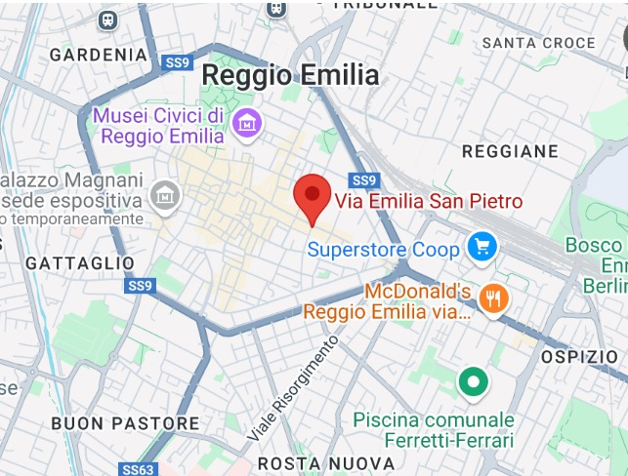

GNYN XYWJMJRN

fYiiY [^gmkh lmhkb[h

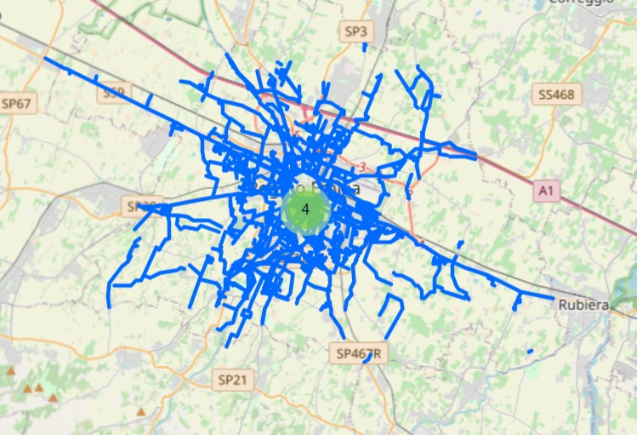

AQLRJKQRQY_

KYiiY - iblm^ [b[eYZbeb

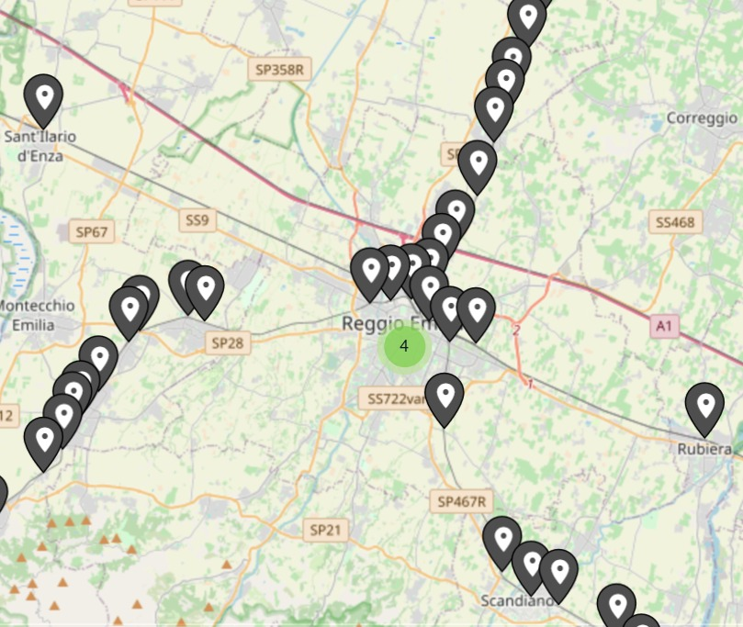

IWJXVUWYU VZKKRQLU

KYiiY Jbg^^ E^kkhobYkb^

