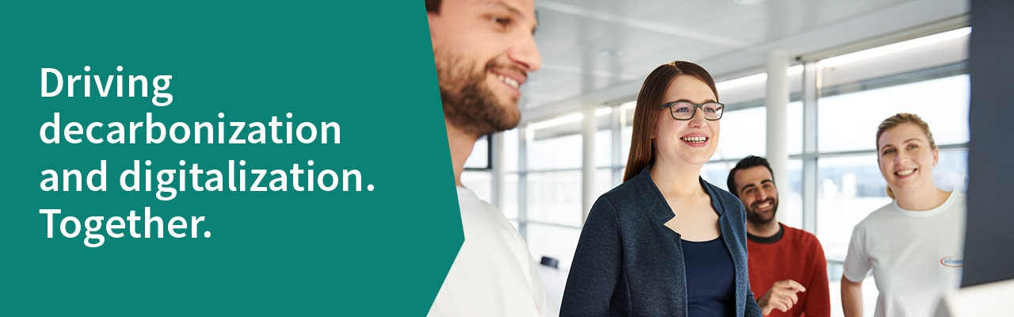



Senior Engineer Maintenance Job description
In your new role you will:
Increase in responsibilities with competency level and technical expertise acquired through professional experience on the job according to targeted role.
Extensive technical knowledge of assigned functional area in Frontend or Backend.
Good knowledge of supplier / customer process in assigned area and how performance affects success of the business.
On-the-job training to more junior colleagues.
Resolves problems both technical and business related.
Local and global communication skills to include documentation, supporting, negotiating, presentation, team contribution and training.
Perform all tasks and responsibilities of own duties to be referred toas a specialist or expert.
Contribution to continuous improvement programs via initiating and executing projects to improve Overall Equipment Efficiency, in term of Speed , Cost and Quality.
At least meet KPIs (Availability, Reliability, Cost & Yield) for assigned equipment
ownership.
Troubleshoot equipment failures, implement corrective action and preventive actions.
Responsible for start-up until RFP (prelease for production) of new or transferred used equipment to support production ramp.
Work together with process engineer to resolve quality issue.

At a glance
Location:
Job ID: HRC0739227
Start date: as soon as possible Entry level: 1-3 years
Type: Full time Contract: Permanent
Apply to this position online by following the URL and entering the Job ID in our job search.
Alternatively, you can also scan the QR code with your smartphone:
Job ID: HRC0739227
www.infineon.com/jobs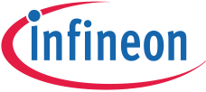

Profile
You are best equipped for this task if you have:

You are best equipped for this task if you have:
Bachelor Degree in Engineering.
Approximately 0-1 years of relevant experience in semiconductor industry. Sounder understanding of principles and concepts in own technical/specialist
area.
Strong knowledge of functional area.
Ability to provide on-the-job training to more junior colleagues to be developed. Train new engineers, interns and more junior technician in functional area.

Benefits
Kulim: Coaching, mentoring networking possibilities; Wide range of training
offers & planning of career development; International assignments; Different career paths: Project Management, Technical Ladder, Management & Individual Contributor; Flexible working conditions; Holiday child care; Medical coverage;
On-site social counselling and works doctor; Health promotion programs; On-site gym, jogging paths, beachvolleyball, tennis & soccer court; On-site canteen; Private insurance offers; Flexible transition into retirement
Why Us
Driving decarbonization and digitalization. Together.
Infineon designs, develops, manufactures, and markets a broad range of semiconductors and semiconductor-based solutions, focusing on key markets in the automotive, industrial, and consumer sectors. Its products range from standard components to special components for digital, analog, and mixed-signal applications to customer-specific solutions together with the appropriate software.
We are on a journey to create the best Infineon for everyone.
This means we embrace diversity and inclusion and welcome everyone for who they are. At Infineon, we offer a working environment characterized by trust, openness, respect and tolerance and are committed to give all applicants and employees equal
opportunities. We base our recruiting decisions on the applicant´s experience and skills.
Please let your recruiter know if they need to pay special attention to something in
order to enable your participation in the interview process.

