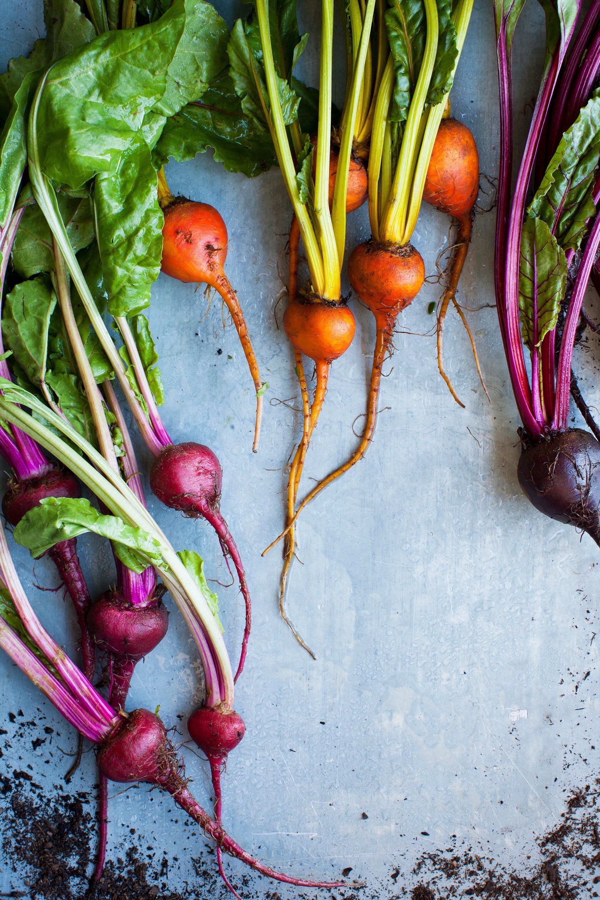

Whitestone Farm
ORGANIC SINCE 2004

Welcome to our working farm
We’re really glad you’re here, and we look forward to showing you around.
Since this is a working farm, it’s important that you stay with your guide at all times and that you don’t feed any of the animals along the way. There will be plenty of
opportunities to feed the animals in the afternoon.
Enjoy your day, and please feel free to ask lots of questions. We love questions.

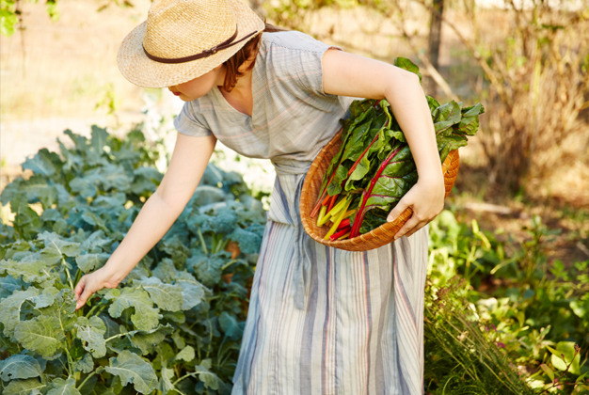
RISE AND
SHINE

Welcome to Whitestone Farm.
We’re excited to show you around and introduce you to our farmers
as well as a few of our furry and feathered friends.
You’ll spend the morning visiting
our fields, learning about farming practices, and seeing how a working
farm operates. You’ll then pick the vegetables for your lunch, and in the afternoon you’ll get to meet
the animals.
“Igot to plant sugar snap
peas and harvest some kale and squash.”
Katie, age 10

9:00–10:30 AM
TOUR OF OUR CROP FIELDS, KITCHEN GARDEN, AND DAIRY
Your guide takes you around the farm and shows you how to plant lettuce and spinach.

10:30–11 :30
PICK YOUR OWN LUNCH
Choose your favorite vegetables from our Kitchen Garden.

11 :30–1:15
MAKE YOUR OWN LUNCH (AND EAT IT)
Our chef shows you how to make a delicious, healthy meal from the ingredients you chose.
We grow tomatoes and micro leaves in our hidden greenhouse. Keep an eye
out for it.

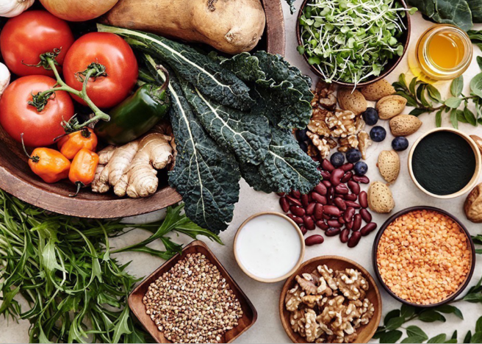

PICK YOUR OWN LUNCH

We’ll split into three different
groups, and each group will pick the ingredients needed for a salad
or a vegetable dish that we’re going to eat for lunch. Once your group has picked everything, you’ll then go to the kitchen to meet our chef, Rachel, who will help you prepare your dish.
Our recipes are dependent on what is in season. The recipes you’re going
to choose from today are:
•Lean Green Machine
•Most Roast Veg
•Bean to Town

“Picking my lunch and
then eating it was awesome.
I’ve never eaten arugula before, and it’s delicious!”
Robert, age 9

Lean Green Machine
Serves 2
Ingredients:
A large handful of spinach A large handful of kale
Half a head of broccoli, chopped into florets A big handful of sugar snap peas
3.5 ounces feta cheese, crumbled
A small bunch of basil, roughly chopped¼cup lemon juice
2 tablespoons olive oil
Splash of white wine vinegar
2 tablespoons pumpkin seeds, toasted
Heat a medium pan of water. When the water is boiling, add the broccoli and cook for2–3minutes. Take off heat and allow to steam.
After washing the other vegetables, toss the spinach, kale, sugar snap peas, and cooked broccoli into a big
bowl. Mix together by hand.
Crumble in the feta and add the lemon juice, olive oil, white wine vinegar, and chopped basil. Mix together by hand, season, and sprinkle with toasted pumpkin seeds.

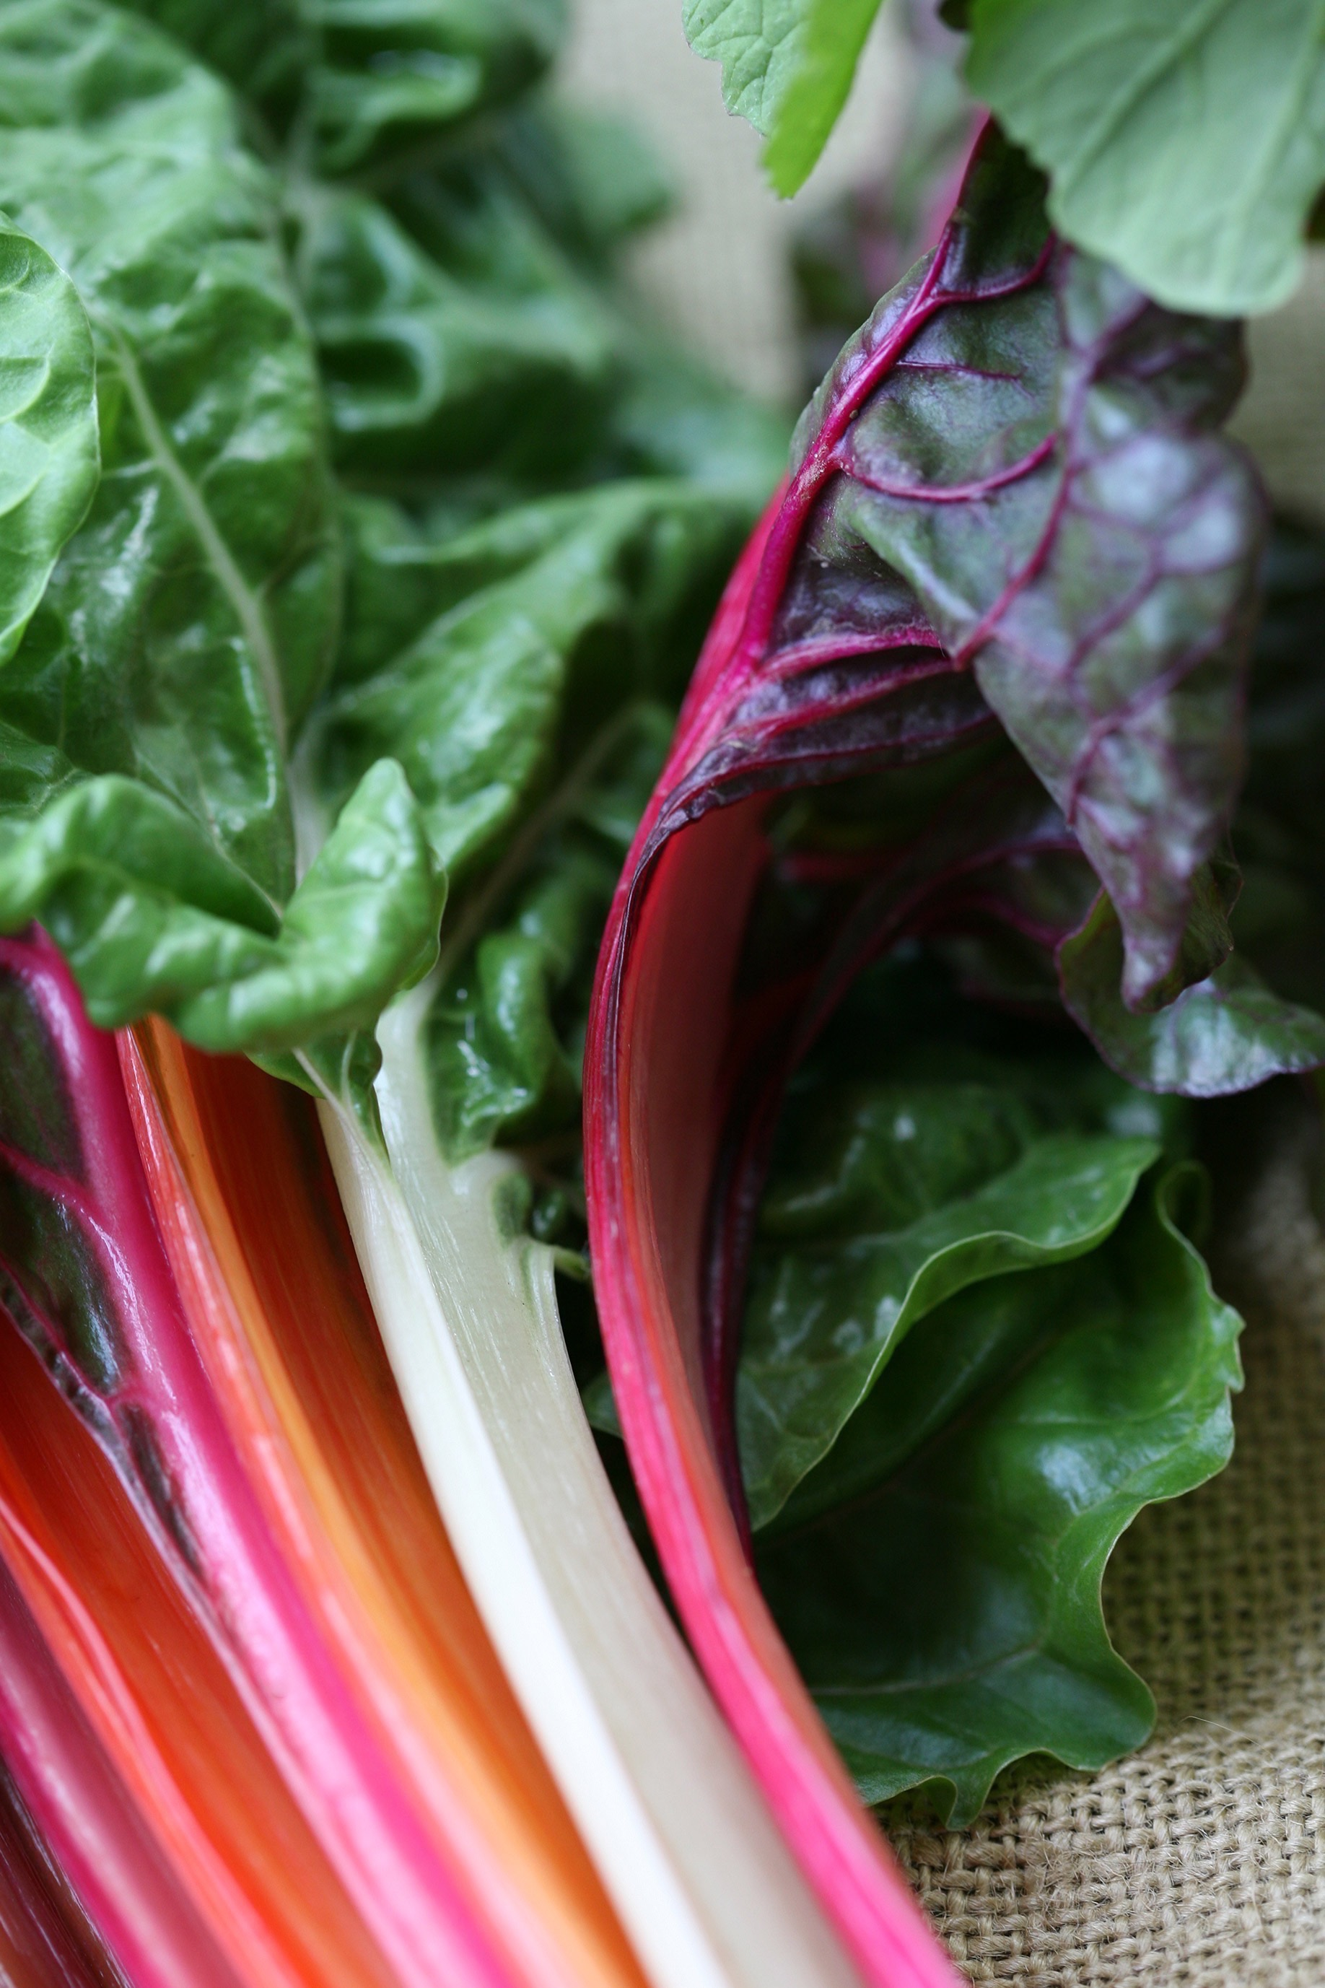

In veg we trust
We’ve been growing vegetables since 2004, and we rely on them for our livelihood and our meals and to keep our farm going. That’s why so much time, effort, and love goes into looking after
our vegetables.
Nothing gets wasted at Whitestone Farm. We compost everything and use this nutrient-rich mixture to grow more vegetables.
Crop rotation
We move our crops around throughout the year so we get the most out of the land.
 | FIELD 1 (5 ACRES) |  | FIELD 2 (7 ACRES)
 | YEAR 1 Carrots |  | YEAR 1 Turnips
 | YEAR 2 Zucchini |  | YEAR 2 Beets
 | YEAR 3 Onions |  | YEAR 3 Potatoes
 | YEAR 4 Broccoli |  | YEAR 4 Leeks
 | FIELD 3 (2 ACRES) |  | FIELD 4 (3 ACRES)
 | YEAR 1 Celery |  | YEAR 1 Tomatoes
 | YEAR 2 Pumpkins |  | YEAR 2 Cabbages
 | YEAR 3 Cauliflower |  | YEAR 3 Spinach
 | YEAR 4 Peas |  | YEAR 4 Sweet corn

RISE AND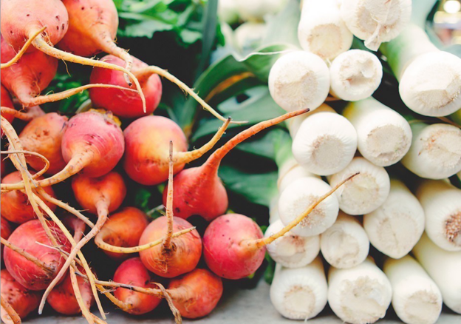
SHINE

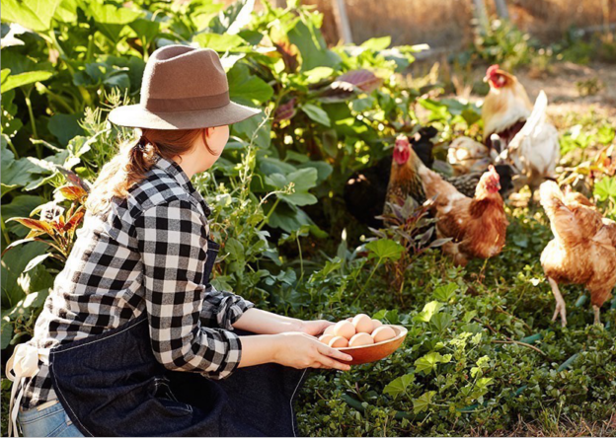

Guy is our head farmer. He grew up on this farm and has been running it since 1995. He knows the land like the back of his hand and could probably plow a field
in his sleep.
Guy is going to take you around the farm to meet the animals, and then you’ll get to vote on which
activity you would like to do for the rest of the afternoon.
Activities
PIGS: SLOP FEEDING
HENS: HEN COOP TOUR AND EGG COLLECTING
LAMBS: BOTTLE FEEDING
SHEEP: SHEARING AND DIPPING DEMONSTRATION
LLAMAS: WALKING AND BRUSHING

“Myfavorite part was seeing all the tractors and then getting to sit on
one.”
Michael, age 8

Things to look for
—Our rooster, Teddy. He likes to strut.—The new raised beds made from old
scaffolding planks.
—Our long-haired Romney sheep, which come from Kent in England.
—The llama-grooming beauty parlor.—The Kitchen Garden and brand-
new greenhouse.
—Our Rhode Island Red hens. They lay brown speckled eggs.

