U.S. Department of Justice
Civil Rights Division
Disability Rights Section
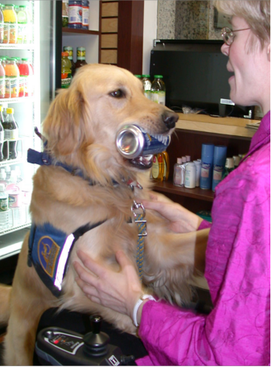

Americans with Disabilities Act
ADA Business BRIEF:
Service Animals
Service animals are animals that are individually trained to perform tasks for people with disabilities–such as guiding people who are blind, alerting people who are deaf, pulling wheelchairs, alerting and
protecting a person who is having a seizure, or performing other special tasks. Service animals are working animals, not pets.

• Businesses that sell or prepare
food must allow service animals in public areas even if state or local health codes prohibit animals on the premises.
• A business is not required to provide care or food for a service animal or provide a special location for it to relieve itself.
• Allergies and fear of animals are generally not valid reasons for denying access or refusing service

Under the Americans with Disabilities Act (ADA), businesses
and organizations that serve the public must allow people with disabilities to bring their service animals into all areas of the facility where customers are normally allowed to go. This federal law applies to all businesses
open to the public, including restaurants, hotels, taxis and shuttles, grocery and department stores, hospitals and medical offices, the- aters, health clubs, parks, and zoos.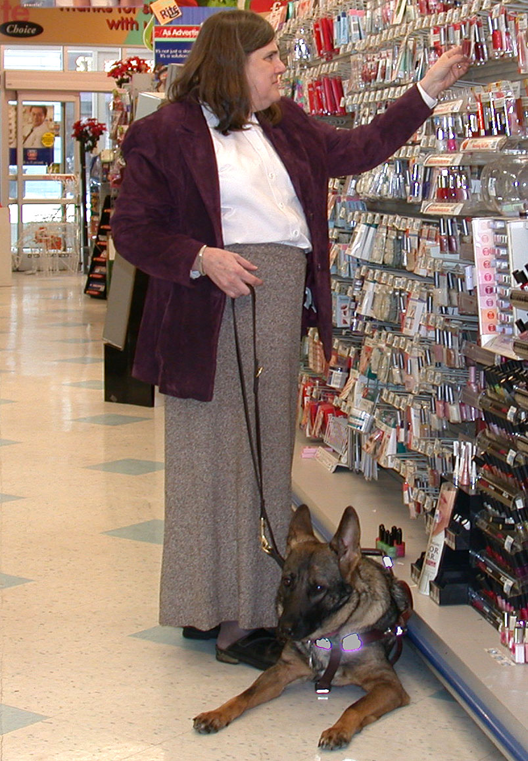

Businesses that serve the public must allow people with disabilities to enter with their service animal
• Businesses may ask if an animal is a service animal or ask what tasks the animal has been trained to perform, but cannot require special ID cards for the animal or ask about the person’s disability.
• People with disabilities who use service animals cannot be charged extra fees, isolated from other patrons, or treated less favorably than other patrons. However, if a business such as a hotel normally charges guests for damage that they cause, a customer with a disability may be charged for damage caused by his or her service animal.
• A person with a disability cannot be asked to remove his service animal from the premises unless:
(1) the animal is out of control and the animal’s owner does not take effective action to control it (for example, a dog that barks repeatedly during a movie) or (2) the animal poses a direct threat to the health or safety of others.
• In these cases, the business should give the person with the disability the option to obtain goods and services without having the animal
on the premises.
to people with service animals.
• Violators of the ADA can be required to pay money damages and penalties.

Service animals are individually trained to perform tasks for people with disabilities
If you have additional questions concerning the ADA and service
animals, please call the Department’s ADA Information Line at
(800) 514-0301 (voice) or
(800) 514-0383 (TTY) or visit the ADA Business Connectionat
www.ada.gov
Duplication is encouraged. April 2002

