THE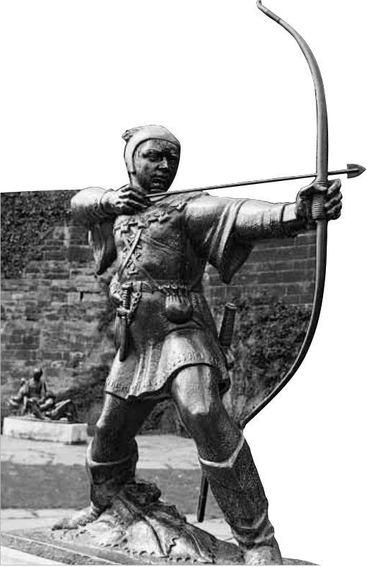
N
ewsLetter
No. 161 The University of Nottingham

October 31 1997

Page three Page five Campus Arts
●Slashing ●Department merger ●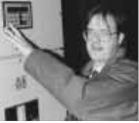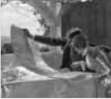

In pursuit

the energy bills across
campus
will help meet the needs of the construction industry for the 21st-century
of leisure ... Victorians at play

Robin makes it to the Big Apple
O

Photograph provided by Nottingham City Council
ne of the worldÕs most enduring legends came under the spotlight at an
international conference this month, as a Nottingham academic joined delegates from all over the world to discuss a centuries-old folk tale.
Outlaw and all-round good guy Robin Hood was the focus for the first ever international gathering in New York of scholars specialising in aspects of the legendÑthey included Helen Philips from the UniversityÕs Department of English Studies who spoke on the role of names in the Robin Hood texts.
There are already plans for a second International Robin Hood Conference to be held in Nottingham at the University in 1999.
ÒA feature of Robin Hood material is the range of forms in which the legend is told: plays may have been the earliest medium for the stories in the Middle Ages; there are also ballads, broadside printed
editions, childrenÕs literature, TV and film, pantomimes, cartoons, novels
and poetryÑKeats wrote on Robin Hood as a radical. The hero has also inspired all sorts of popular sayings, from ancient proverbs to modern newspaper headlines and adverts, especially in Nottinghamshire,Ó said Helen Phillips.
ÒIt is the development of academic interest in popular culture, popular and protest literature, film studies and also in non-standard and non- authoritative genres, that has made this long-lived legend of interest to researchers in many areas. The conference included films, music, performance and an exhibition of art with Robin Hood as a theme.Ó
Ms PhillipsÕ particular area of interest in the legend is the place names which occur in ballads and the paper she presented focused on:
Outlaws and Forests, Places and Plots:
The Role of Names in the Robin Hood Texts.
(Continued on page two ...)

News◆ Research Focus◆ Across The Quadrangle◆ Campus Arts◆ Student View

1

~ News ~
International stage for Robin

S

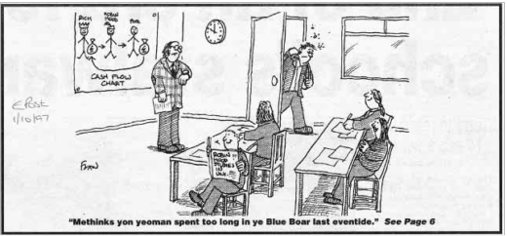

The University of Nottingham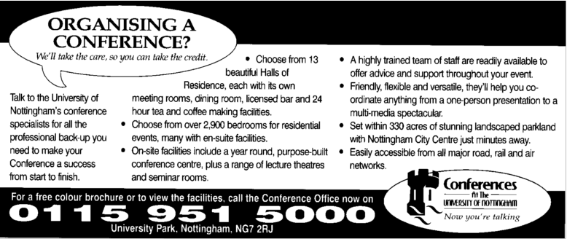

ome of the ballads set Robin in YorkshireÑhe goes fishing at Scarborough
in oneÑand sometimes the claims
of other regions have seemed to threaten NottinghamÕs own pre- eminence as Robin Hood country.
There have been two pieces in the Nottingham Evening Post (see cartoon, left) about the conference and the research on the legend and

THE
N
ewsLetter
Published fortnightly during term time by the
Public Affairs Office, University of Nottingham NG7 2RD
Telephone: 0115 951 5765 Facsimile: 0115 951 5733
Editor/designer:
Lyn Heath-Harvey (ext 15798)
e-mail:
Lyn.Heath-Harvey@nottingham.ac.uk
Contributors: Philip Dalling, Liz OÕNeill and Katrine
Scott-Mitchell
What's On, What the Papers Say
and advertising
(rates on application) :
Barbara Sandford (ext 15798) The Editor reserves the right to refuse advertising. The
University does not necessarily endorse any products or services advertised.
Contributions from staff and students of possible news stories, features and other
items are welcomed and should be sent marked NewsLetter, to the Editor. Produced by the
Public Affairs Office
Extracts from NewsLetter should not be reproduced without prior permission from the Editor
Printed by
The Sherwood Press
(Nottingham) Limited
(... continued from page one)ÒPart of what I am doing is to
suggest solutions to some hitherto unidentified or uncertain local references, including some in Rutland and Cumbria, in ballads from the 15th- to 17th-centuries. But the paper is not concerned with the sort of literal hunt to track down a real historical Robin HoodÑwe canÕt know if there was a real person behind the legend.
ÒThe legend and its almost
infinite capacity for transformation is the subject of the conference. My particular research is concerned
more with the role of names and places in the ballads.Ó
She added that, on one hand, geography is essential to the Robin
Hood legend: a terrain of three elementsÑthe forest, the highway and the (dangerous) townÑis central to it, yet this terrain of the plot is not essentially localised. Not even to Nottingham and Sherwood.
Other regions appropriate the Robin Hood myth. She highlighted two in particular: StaffordshireÑNeedwood Forest and Tutbury; and CumbriaÑInglewood Forest, a location also for King Arthur in
some medieval romances. There was even a Scottish Robin Hood.
ÒMy paper asks why, when the adventures can happen anywhere
that has the elements of the essential geography, placenames turn out to be so important in the Robin Hood ballads and what significance they have,Ó she said.
There are already plans for a second international conference at
the University in two yearsÕ time. The Department of English Studies has already a strong research interest in regionality in literary, linguistic and drama studies. It also contains the English Place Name Survey. There is increasing interest in cultural studies in the department, especially in relation to language studies, and Robin Hood ballads already figure in the undergraduate English studies course.
Other Nottingham speakers who attended the international conference at the University of Rochester in New York were Frank Abbott of Nottingham Trent University, who talked about the transference of the legend to a new medium in the city centre-based Tales of Robin Hood, and Michael Eaton, who talked about his award- winning film Fellow Traveller and his short film Moving Pictures on the history of Robin Hood on film.
the point was made that there is perennial interest from tourists and visitors in the Robin Hood legend here in Nottingham.
I am glad to say that my paper points out that some of the apparently Yorkshire references may not be to Yorkshire but bring him back nearer home to the Rutland countryside. There are also other references that tend to
reinforce the specific East Midlands and Nottingham settings of some of
the ballads, which may be a comfort to anyone who fears that academics will spoil the traditional links with Nottingham.
Sometimes the ballad detail shows specific knowledge of Nottingham geographyÑand the sheriff, his castle and prison are clearly Nottingham.
This conference showed just
how big the myth is and has been through the centuries. There is no fixed, original Robin Hood tale which is the ÔrealÕ story. Robin Hood can be everywhere and nowhere, but he is also often located somewhere in particular and, over the centuries, Nottingham and Sherwood have been the most important places.

2

~ News ~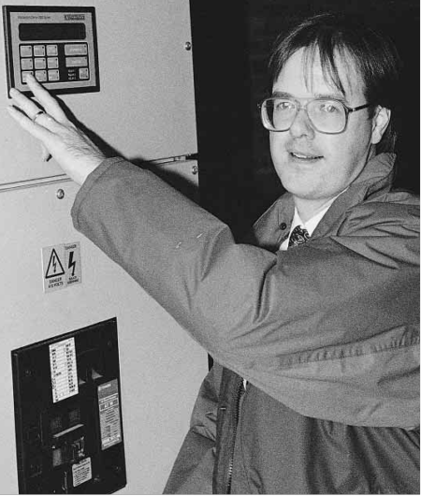
Switch it off!

S

taff and students at the University are being urged to be Ôenergy- awareÕ in a bid to slash rising bills.
The University spends around £4.5 million on energy and water every yearÑbut an estimated £500,000 of that is waste, for example from leaving lights on in unoccupied rooms.
Energy Management Engineer Tim Rudge took up his post in February. He
is keen to encourage individuals to cut the amount of energy each of us wastes each year by using resources more wisely.
ÒA lot of good work has already been done. Over the last five years, the
University has invested heavily in modern gas boilers and computerised heating controls. However, what was missing was the ability to make informed decisions on where energy was being wasted, because we had not been keeping records for
most of our buildings,Ó said Mr Rudge.
performance in future years and decide where further investment in new equipment is required. Although we have reduced our usage of heating fuels over the last few years, our electrical power consumption has risen by an alarming 15 per cent, principally due to the introduction of IT equipment. Buildings are being used much more intensively, with evening, weekend and holiday usage becoming more commonplace.
ÒI certainly donÕt mean by that that we should all sit in the cold with the lights
outÑpeople have a right to work in comfortable, well-lit buildings. What IÕm talking about is eliminating needless waste and using resources more widely.
ÒThe effort of each individual is significantÑwith many thousands of people on our campuses, any small improvements soon mount up if people make an effort.Ó



● Main photo: Tim Rudge checking on electricity consumption. Inset: just
one monthÕs electricity bill for the University.
leave a room for a period of timeÑeven fluorescent tubes

ÒThe major part of my first year has
been spent on creating a database of ●
TimÕs energy-saving tips include:
Report overheating to the Estate
●Switch off your computer monitor when you leave the roomÑyou can leave the base unit on it it to be used later

energy and water consumption, so that Office so the problem can be remedied For further advice on energy management contact Tim Rudge we can accurately measure our ●Switch off unnecessary lights when you on ext 13583 or by e-mail at: tim.rudge@ nottingham.ac.uk

New rehabilitation initiative launched at Derby unit
Universities boost UK economy, report reveals

T
M
he UniversityÕs equipment designed for people with oney spent on ●in 1995/96 the higher

Rehabilitation Research Unit based in Derby has
obtained a further boost and continued recognition as a centre of excellence in specialist rehabilitation.
It has been awarded a contract of£135,000 a year for five years to establish the third National Disability Equipment Assessment Centre. The funding will be provided by the Department of
Health through the Medical Devices Agency and was won outright in the
disabilities. The centre will be staffed by a research co-ordinator, a centre administrator, a clerical assistant and by sub-contracted staff seconded from within the region. This will allow appropriate professional expertise to be recruited as necessary and will provide research and development opportunities for those involved.
The assessment centreÕs management group includes:
Professor Chris Ward (University of
universities is money well spent, according
to a recent report which shows investment in higher education has a major impact on the UK economy, boosting industry and generating wealth and jobs across all sectors.
The report, The Impact of Universities and Colleges on the UK Economy, reveals that in addition to fulfilling their core mission of education and research, universities serve as vital players in the economy:
education sector had an estimated balance of trade surplus of £1.3 billion. Every £1 million of total expenditure by higher education institutions generates £2.21 million
of output in other sectors of the UK economy
Commissioned by the
Committee of Vice-Chancellors and Principals (CVCP) and sponsored by business lawyers Eversheds, the research was conducted by Professor Iain McNicoll and colleagues from

face of competition from other Nottingham), Maeve Groom ●the higher education sector the University of Strathclyde.

centres. The centre will be run by the UniversityÕs unit, in partnership with the Derby City General
(Derby City General Hospital), Dr Lorraine Pinnington (University of Nottingham), Dr Christian Murray-
provides jobs, either directly or indirectly, for more than three per cent of the total UK workforce
ÒUniversities underpin the UK economy. This report shows money
invested in universities is hard

Hospital, the Derbyshire Royal Leslie (Derbyshire Royal Infirmary), ●business worth £43.19 billion working cash. Not only does it ÔbuyÕ

Infirmary and the Derbyshire Community Health Services NHS Trust.
It will provide a needs-led evaluation programme for the assessment of aids and assistive
Dr David Pratt (Derbyshire Royal Infirmary), Chris Bould (Derbyshire Community Health Services), Julie Spicer (Derby City General
Hospital) and Philip Gerard (Disability Direct).
is generated across the economy by the higher education sector, which spends £12.58 billion on goods and services produced in the UK
(equivalent to 2.1 per cent of UK Gross Domestic Product)
education and high level skills for the nation, but it has a powerful knock-on effect, bringing wealth and jobs to other industries,Ó said Diana Warwick, chief executive of CVCP.

3


~ Research ~

Research Committee events

University soirée and presentation planned

are to bring together relatively new lecturers from all faculties: to identify research Ôhot-spotsÕ to

executive of the ESRC, is visiting the University on Friday November 7. He will give a

● New LecturersÕ Research These summaries of research form the basis of pan-Nottingham presentation about the ESRCÕs

SoirŽe
The Research Committee and Training and Staff Development Unit are holding a research soirŽe for new lecturers on Tuesday November 4 from 4Ð5.30pm in the Delta Suite at the University Staff Club
The aim of this soirŽe is to bring together the different
departments and people who have an interest in newer research initiatives. Each participant will be invited to submit on one side of
interests will be published on the Virtual Research Office page following the event.
The soirŽe will be chaired by Professor David Wood
(Psychology) and chairman of the Research CommitteeÕs Humanities Strategy Group. Dr Richard Aldrich (Politics) and Ian Campbell (Manufacturing Engineering and Operations Management) will be giving their first-hand experiences, as previous recipients of awards when they
applications for new project support; to appreciate strategic issues determining the policies of funding bodies; to allow researchers to exchange summaries about their work and plans and to influence future initiatives aimed
at supporting new researchers.
If you wish to attend the soirŽe you should contact Sue Renshaw either by phone on ext 15741 or by e-mail to: Susan.Renshaw@ nottingham.
role, its methods for supporting research and the latest thinking
that will determine how research funds are allocated in the future.
The presentation will take place in the Senate Chamber, Trent Building, at 2 pm. All those who have an interest in the ESRC, whether considering applying for
a project grant or being part of a team that is applying for multidisciplinary programme grants or a student in receipt of an ESRC grant, should attend this

A4 a rŽsumŽ of their research were new lecturers to the ● Presentation by Professor presentation. There will be

interests, to be displayed at the soirŽe, to facilitate communication between researchers relatively
new to this University.
University, of obtaining and benefiting from these awards from the Research Committee.
The objectives for this soirŽe
Ron Amann, chief executive
of the Economic and Social Science Research Council
Professor Amann, chief
opportunities to question and discuss with the ESRC chief executive current priorities and future funding opportunities.



4

~ News ~
Departments merge to form new School of the Built Environment

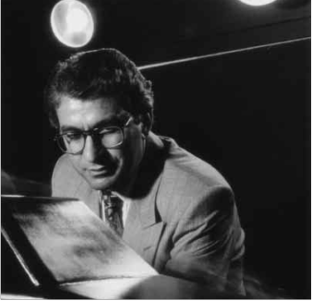
T

he Department of Urban Planning is being merged with the Department of Architecture and Building Technology
to form a new School of the Built Environment. The new school, to be launched tomorrow,
will be headed by Professor Saffa Riffat and consists of the Institute of Architecture, Institute
of Building Technology and Institute of Urban Planning.
The aim of the school is to bring together architects, engineers and planners to carry out interdisciplinary teaching and research in innovative ways to meet the need of the construction industry for the 21st-century.
Meet the need
Academic staff of the three institutes will be based in the building currently occupied by the Department of Architecture and Building TechnologyÑWortley HallÑwhile the Urban Planning building, Paton House, will
become a centre for postgraduate studies.
ÒThe merger of the two departments will allow more effective use of resources including secretarial staff, technicians, computer and workshop facilities,Ó said Professor Riffat.
ÒStudents from the three disciplines will use the same studio space and will be encouraged to work
on their design projects as part of a team involving architects, engineers and planners. This should allow better integration of architectural design, planning and servicesÑa feature often lacking in many modern buildings.Ó
This month, the school launched a new MSc course in renewable energy and architecture, which encourages architects and engineers to work together to design buildings which useÔenvironmentally-friendlyÕ technologies for heating, cooling and power generation.
In October next year, the school intends to launch an innovative degree, MA Eng, which will produce graduates with a dual qualification in architecture/building services engineering.

● Professor Saffa Riffat
Accreditation of the new degree will be sought from the RIBA/CIBSE. It is also intended to launch in the near future another interdisciplinary degree involving architecture and planning.

Campus welcomes World Games
T

he University was chosen as one of five venues this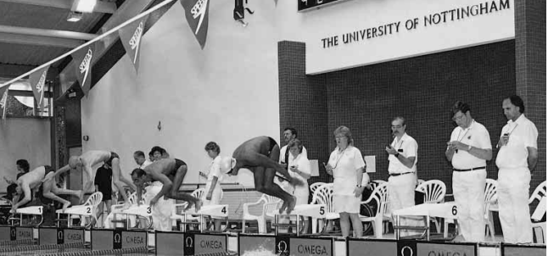
summer to host the 1997 World Games for people with cerebral palsy.
The eventÑknown as the Robin Hood Games because of its association with NottinghamÑattracted nearly 900 competitors from 37 countries to take part in nine different sports.
ÒTo welcome Žlite
athletes to the University is an honour and these athletes were Žlite in every sense of the word,Ósaid Diane Hardwick of the Sports Centre.ÒMany of them already have their sights set on Sydney 2000 and several are already paralympic medallists in their own right.Ó
The University was selected as a venue for the boccia and swimming competitions, while other eventsÑincluding athletics, football, powerlifting, canoe slalom and sprint, table tennis, bowls and cyclingÑ

were held at other venues within the city. The Cerebral Palsy International Sports and Recreation Association (CP-ISRA) is one of the youngest international organisations for sports for
the disabled, but has one of the largest memberships. It works alongside other disability sports federations to give an identity to people with cerebral palsy and provide greater
opportunities to show that even those with a severe disability can compete at the highest levels.
Cerebral palsy is a condition of great
complexity. Brain damage, usually caused at or around birth, has many effects and lack of balance and co-
ordination, communication difficulties and many other conditions may result.
Normal learning patterns in terms of movement and co-ordination are never experienced, consequently, participation in sport poses particular challenges. Specific coaching
techniques are required and, for the purpose of competition, classification is necessaryÑallowing for groups of people with similar types of abilities to compete against one another.
ÒTaking place over nine days, the games took place in a wonderful atmosphere of friendly rivalry, team spirit and genuine joy and
camaraderie shown by all teams as they celebrated
one anotherÕs triumphs and commiserated with each other in their disappointments,Ó said
Diane.

5

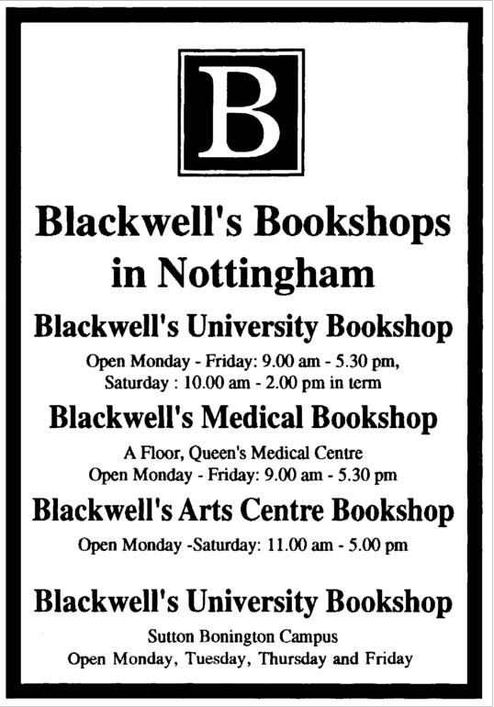
~ University News ~

EMCC cooks up tasty partnership

S
taff at the East Midlands Conference Centre have cooked up a tasty partnership with the prestigious
Hilton Park Lane.
In a bid to give the EMCC service extra sparkle, the conference and banqueting team has invited leading industry specialists to take part in its latest quality review.
Hilton Park Lane director of banqueting David Irving spent a day shadowing EMCC front of house manager Michael
Wilcockson in a Ôno secretsÕ review and plans are now in the pipeline for EMCC chefs to visit London and to work in the Hilton kitchens.
ÒRegular quality reviews provide us with an opportunity to make improvements and changes which we feel will offer added value to our customers,Ó said conference manager Malcolm Youngson.
ÒWe were delighted when the Hilton Park Lane agreed to share their expertise

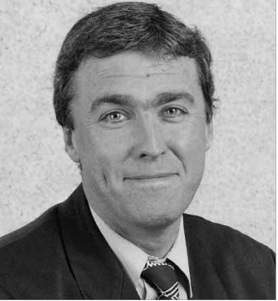

●Malcolm Youngson, Conference Manager at the EMCC
with us by providing an outsiderÕs opinion
on our conference and banqueting

Top London hotel shares tricks of the trade
operations. The feedback received so far has proved extremely useful.Ó
He said that as Investors in People, the EMCC was committed to developing its staff in line with the objectives of the business and the Hilton Park Lane partnership provided everyone with an
opportunity to review both their operation and ways of working.
ÒIn an extremely competitive business it is vital that we do everything we can to ensure total customer satisfaction,Ó he added.

Courtyard update
A

n end is in sight to the extensive work being
carried out on the Trent Building, Estates staff have promised.
It has been a long hot summer of noise, dirt and scaffolding for staff who work in the building, but the courtyard and refurbished main entrance will re-open to through- traffic on Monday November 3.
The programme of refurbishment has included cleaning the stone facade of the listed building, relaying and replanting the courtyard and improving disabled access.
However, the project ran into problems part-way through when the stone supplier hit a bad seam and could no longer guarantee the consistency of the stone. Another supplier had to be found quickly and
work phased to coincide with supply.ÒWe can only apologise to those
who have been affected by work both inside and outside the Trent
BuildingÑwe have done our best to bring the project back on track as quickly as possible,Ó said Director of Estate Management Chris Jagger.
ÒIt has been a particularly sensitive project because Trent is a listed building and we had to ensure that all work was carried out sympathetically. However, we have researched
what the original 1920s layout of the courtyard would have been and
the new planting and turfing scheme brings us closer to those plansÑIÕm confident that the result will be worth the wait.Ó
The service road at the rear of the building will be closed for two or three weeks from November 17 to allow workmen to complete cleaning
of the final elevation, but diversions and traffic flow arrangements will be made (see next NewsLetter).
Any other remaining work will involve only short periods of closure
outside normal working hours.

All public and inaugural lectures will in future be advertised
on the back page of NewsLetter in the ÒWhatÕs OnÓ section. The aim is to promote the lectures to a wider
circulation, therefore the customary public and inaugural lecture card will no longer be published.

6

~ University News ~
A spot of bother

A

multidisciplinary team of researchers from the University and Leeds has been awarded £433,000 by the NHS
Research and Development Health Technology Assessment programme to look in depth at a skin
complaint that affects between 20 and 30 per cent
of 15Ð25 year-olds in the countryÑacne.
This is the first major award to be given solely to the study of a dermatological problem. The project, which started in August, will evaluate the use of antibiotics in mild to moderate acne in the community. For the purpose of the study, mild to moderate acne is defined as pimples sufficient to seek medical help from a general practitioner.
The team includes Dr Hywel Williams
(Medicine and Health SciencesÑDermatology), Professor Mike Pringle (Medicine and Health SciencesÑGeneral Practice), Professor Alain Li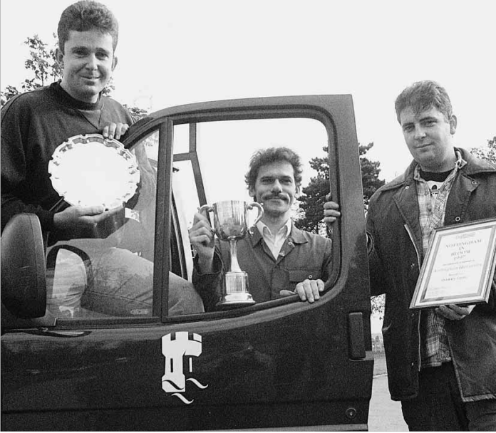
Wan Po (Pharmaceutical SciencesÑClinical Pharmaceutics) and Dr Dave Whynes
(EconomicsÑHealth Economics) from Nottingham and Dr Anne Eady (Microbiology) and Professor Bill Cunliffe (Dermatology), Leeds.
Difficult decisions
To date, no one has looked at the comparative effectiveness of the many antibiotic products available for use in this condition. GPs are faced with difficult decisions when trying to work out the best treatments for their patients.
The main focus of the three-year study will be to try and establish which products are the most effective and cost effective in treating acne and more about the pattern of bacterial resistance to the antibiotics that are used. The overall aim is to
establish national guidelines for the management
of acne in the community.
The trial will be a community-based randomised controlled clinical trial recruiting
1,200 patients from GP practices in the Leeds and Nottingham areas. All patients will be randomly allocated one of 11 different treatment schemes. Each scheme includes a cream and a tablet.
Dr Williams explains one of the major differences about this trial. He says: ÒUnlike many
other clinical trials, we will be placing emphasis on how our patients feel about their acne both before
and after treatment. We will, of course, also be looking at more objective outcome measures like the number of inflammatory spots and facial redness and will take pre- and post-treatment pictures to help in our evaluation of the treatment methods.Ó
T

Flower power
TQA success
he Department of Urban Planning has scored 23 out of a possible 24 marks in the latest Teaching Quality
Assessment. The marks were: curriculum design content and organisationÑ4; teaching learning and assessmentÑ3; student progression and achievementÑ4; student support and guidanceÑ4; learning resourcesÑ4; and quality assurance and enhancementÑ4. ÒYet another fantastic result for a Nottingham department,Ó said Director of Teaching Enhancement Alan Howe.
F

U
niversity grounds staff are celebrating after helping Nottingham to win the overall
Britain in Bloom large city trophy for 1997. And the team came third in the overall city winners for NottinghamÑthey were pipped to
the post by Wollaton Post Office and

Nottingham Hospice. Pictured above are:
Simon Robinson, Michael Wroblewski and Ray Sturman. The city will now go forward
next year to EuropeÕs Entente Floral.
ÒItÕs nice to know that we at the University did our bit to help with that success,Ó said Grounds Superintendent Ian Cooke.
Crab appeal
our members of the security staff at the University of Birmingham are undertaking a charity bicycle ride from
Plymouth to Aberdeen in aid of the CRAB (Cancer Research at Birmingham) appeal,
calling at other universities on the way. They will call at Nottingham on November 3Ð4, and are appealing to staff and students to support them with donations. Money can be handed to the participants on the ride or cheques made
out to the Cancer Research Campaign sent to:
K Whitehouse/E Cox, Security Section, University of Birmingham, Edgbaston Park Road, Birmingham.

7

~ News In Brief ~
Is an

M
artin Reed, Professor Trevor Benson, Professor Peter Kendall and Dr Philip Sewell of the
Department of Electrical and Electronic Engineering have been awarded the JJ
Ghoulies and ghosties and long-legged beasties have been been a part of
our folklore for thousands of years. Lyn Heath-Harvey looks at how modern science is turning the cold spotlight of fact onto the paranormal.
I

Thomson Premium by the Institution of Electrical Engineers for their paper Anti- reflection coated angled facet design, which was published in the IEE ProceedingsÑOptoelectronics. This is the second time that Professor Benson has won an IEE Premium award. In 1995 he receive the Electronics Letters Premium with Vladica Trenkic and Professor Christos Christopoulos for the development of a new symmetrical super- condensed node for the transmission line modelling (TLM) method.
O
ne in three people in the UK will have cancer at some time in their
lives ... one in four will die from it. The Imperial Cancer Research Fund is looking for young and enthusiastic people to help to achieve their vision for the future. ICRF employs 1,000 doctors and scientists who are working towards a better understanding, prevention and cure of all kinds of cancersÑthey believe that if current trends continue they will be able to cut the number of cancer deaths by one- third by the year 2020. The charity would like to set up a vision team in Nottingham, a very different type of fundraising group and
one of the first of its kind, with the challenge
of raising £5,000 over the next 12 months. The vision team will not only offer the
opportunity to contribute to the lifesaving work of the ICRF but also to meet new people, make friends and have some fun.
T
he University of AberdeenÕs Department of Forestry is seeking volunteers to help with its 1997
Internet survey research project. Researchers are investigating public preferences with respect to a wide range of landscapes and ÔalternativeÕ forest management systems. The survey is also being used to compare data obtained by conventional door-to-door surveys with that obtained from the Net. The team is looking for more than 500 volunteers nationwide. The survey is open to anyone with a computer and Internet accessÑit is easy to complete, self-contained and simply involves assessing images viewed on the computer screen. The URL for the survey is: http://www.abdn.ac.uk/~for275
tÕs hard to describe, but if youÕve ever felt it, you will know exactly what I mean. A sharp intake of breath, a prickle
down the neck and a distinct impression ... that you are not alone.
Thousands of people every year claim to experience events they feel they cannot explain away by conventional meansÑapparitions, poltergeists, ESP and things that go bump in
the night.
Some would say there are those who have a sixth sense which allows us to detect a supernatural presence or tune-in to someoneÕs thoughts; others would snort with derision and claim the ÔhappeningsÕ are merely the product
of an over-active imagination or too much cheese for supper.
Whatever your standpointÑand, for the record, I am firmly in the believersÕ campÑ
the scientific research done over many years in this field by Dr Alan Gauld of the UniversityÕs
Department of Psychology is gripping stuff. He is far from the Hollywood view of a
ghostbusterÕÑhis work in the field of parapsychology is much-respected and thoroughly scientific.
Dr GauldÕs aim is to apply scientific methods to reports of strange happenings in an attempt to explain them in a rational way. He is open- minded about the subject but says he can explain away the majority of reports of strange events as belonging to an earthly rather than a spiritual dimension. That said, he can also tell a tale spooky enough to give you goosebumps.
Dr Gauld tries to keep out of the media limelight nowadaysÑhe is understandably wary of how his work could be sensationalised
or attacked by those who are hostile for whatever reason. But his eyes have a tell-tale sparkle when he talks about the excitement of a potential paranormal encounter.
ÒI was seven or eight when I embarked on my first supernatural adventure. There was an
old building where strange things were supposed to have happened and I wanted to investigate, but I hit my head falling off a plank and that was an abrupt end to it,Ó laughed Dr Gauld.
ÒUndeterred I retained my interest and joined the universityÕs psychic research society
when I got to Cambridge. One of the first places we went to investigate in the early 1950s was a very old house called Abbas Hall near Sudbury, which was then isolated in the
middle of a field. We had heard that the woman who lived there claimed to have seen the ghost of a nun crossing her room on many
occasions.
ÒIt was wonderfully atmospheric because
there was no electricity, just oil lamps and suits
of armour everywhere and the flames flickered, creating large shadows. It only served to add to
our anticipation when we stopped off for milk at a local shop on the way and a girl heard us talking. YouÕre not going THERE are you?Õshe said wide-eyed.
ÒDuring the night, members of the group
saw lights they could not account for and there was a curious column of cold which you could put your hand into as it moved around. There was also a great noise at the window, as if someone had run their hand down the leaded panes, but I looked out and there was no one around. The highlight of the evening was when one member of the group sitting on the sofa suddenly yelled out that he had seen the nun beside him. I remember he was very upset and breathing heavily.Ó
Another occasion, which Dr Gauld says still plays on his mind as one of the more curious of his many investigations, was at another very
old hall about five miles from Wisbech. It was
occupied by the then local Labour candidate for Wisbech, who later became an MP and
now sits in the House of Lords, plus his wife, two children and mother-in-law.
ÒThe family kept hearing funny noises from upstairsÑraps and bangs and even a shaking bed. We were genuinely not expected anything much to happen, but arrived late one foggy night and assembled the family together downstairs to hear their stories.
ÒWe started them off on a ouija board, mainly as a device to ensure we knew where theyÑand their handsÑwere positioned to eliminate them as culpritsÕ if anything happened. I went upstairs to stand on the first- floor gallery. The temperature suddenly dropped around 10 degrees in a very short space of time and I heard footsteps coming up

8

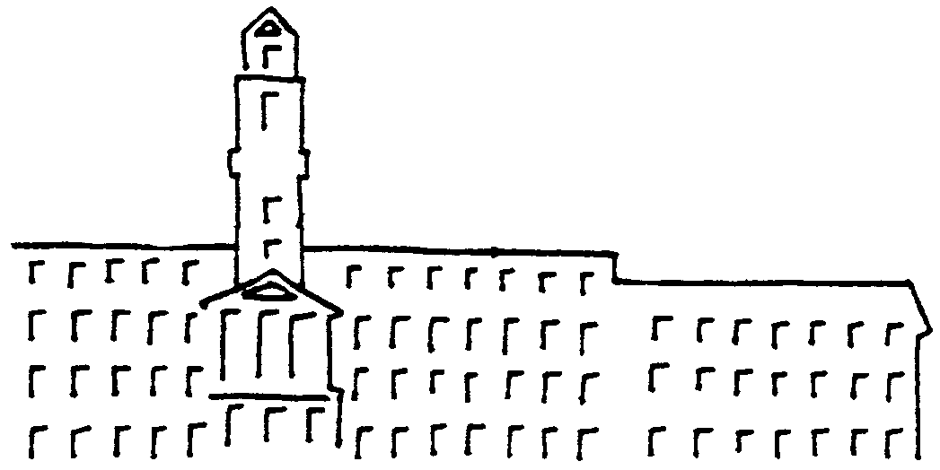

ody there?

Across the Quadrangle
I

the stairs which stopped half-way ... there was absolutely no one there.
ÒThen from a room off the gallery was a loud crack like a rifle going off. A colleague joined me and we settle down in the room on mattresses, presuming nothing more would happen. We tried to sleep but soon heard little taps coming from the floor. We elicited specific patterned replies from the taps and they
travelled and got louder.Ó
There followed a sequence of strange eventsÑa chair stacked on a packing case fell to the floor with no one near it; the taps moved around the room and answeredÕ their attempts at communication; no one was in the room below while the taps were going on and nothing was found between the
floorboards; as they re-entered the room having fetched a third colleague, the door
slammed shut and behind the metal plate
on the door was lodged an old brass toasting fork which had gone through the door
staple, bolting them into the room. Investigation techniques were basic in
the 1950s, but despite careful measuring of the building to rule out any hidden rooms and accoustic experiments to see if the sounds could
have been projected from elsewhere, no rational explanation was to be found.
Dr Gauld said he has investigated many many cases since and has even captured poltergeist activity on
video, but the Wisbech case of 40 years ago still tantalises.
Other areas of more repeatable phenomena, such as extra sensory
perception (ESP) are also an area of interest for Dr Gauld, who has conducted lab-based experiments which he says
are intriguing. This area of science is gaining increasing credibility, in fact, professor of parapsychology at the
University of Edinburgh Robert
Morris has this week gone on record in a national newspaper and will next week state at a public lecture that he is between 90 to 95 per cent sure that humans possess a Òhitherto undocumented ability to communicate with

the world around them.Ó
Using data on fluctuations in the EarthÕs magnetic field, it has been shown that ESP experiments are considerably more successful at times when global geomagnetic activity is low. Now, the work begins to find out why.
So tonight when the lights are dim and you hear a heavy knocking sound, donÕt have nightmaresÑitÕs only the kids playing trick or
treat!! Or is it ....?

Poltergeists by Alan Gauld and Tony Cornell is available at the University Library.

t is not always true that people make the most poignant pictures. A 1940s vintage double decker bus turning off University
Boulevard, past Highfields Lido, with only open space in the distance, is one of the most telling
images of a cine film unearthed in the project to produce an historical Golden Jubilee video.
Living on the University Park campus today, with more than five times as many students and members of staff as in the early post-war years, is still hardly a shoulder-to-shoulder affair. Imagine the feeling of spaciousness in the days when science city and even Portland Building were nothing more than projects in Bertrand HallwardÕs visionary mind. In fact you do not
have to imagine it, as the cine archives capture the atmosphere so beautifully.
As a result of appeals in NewsLetter and The University of Nottingham Magazine two major sources of film have come forward. The Department of Manuscripts and Special Collections has a small but valuable archive, the highlight of which is a 12-minute, 16mm black and white film, made in 1946, entitled Saturday at UCN. This features a male and a female student and follows their progress throughout the day. The boy, Peter R Smith, is seen getting up and shaving in his lodgings, and the coupleÕs progress
is monitored from catching a bus in the Old Market Square to saying goodnight after the Saturday night ÔhopÕ.
The original film was discovered in the Chemistry Department in 1992, transferred to Manuscripts earlier this year and copied on to video. The film was made by an outfit called Photo Tech Film Unit and has full credits. It features both students of UCN and those of Goldsmiths College, still at Nottingham in 1946 as part of their wartime evacuation.
A current task is to try and trace the two starsÕ
of the film. Peter R Smith was a UCN student but neither the Nottingham alumni relations
office or its counterpart at Goldsmiths can trace the girl in the production, Cynthia Bardwell. There is no such problem in the case of the other major item of film offered for the Golden Jubilee tape. Former chemistry reader Dr Stephen Wallwork has supplied cine films of various events on campus in the early fifties, including that of the graduation of his wife-to-be.
Distinguished graduates in the world of television, including Bob Phillis of the BBC and Edward Childs, responsible for much of the best drama seen on ITV in recent years, have offered advice and assistance in helping to realise what is proving to be a fascinating product. One major question remains. Cynthia Bardwell, where are you today?
Philip Dalling

9


~ Campus Arts ~

Artist-in-residence workshops
T

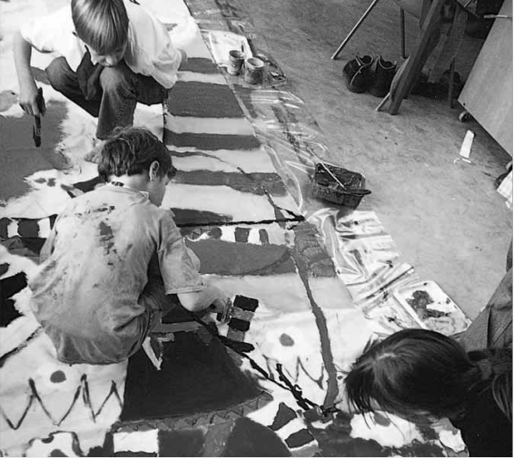

●Banner-making workshop with Heather Connelly, artist-in-residence at the Djanogly Art Gallery.
he Christmas lights are already being hung around
Nottingham, but before you start to panic about the
festive season, why not book
onto a workshop designed to help you make your own cards, wrapping paper and printed fabrics, in the helpful (?) company of your own family.
Creatively
The special family workshop takes place on Saturday December 6, when adults and children will
work creatively together, have some fun and print their own custom-made materials in plenty of time for Christmas. The workshop is led by Heather
Connelly, artist-in-residence at the Djanogly Art Gallery, and is suitable for children
over five, with a maximum
of three children per adult. The fee for the workshop is£15 (£10 concessions) for
one adult and one child, with £5 per extra adult or child.
Heather Connelly will also be revealing the secrets of printing and hand painting
onto fabric in a creative workshop for adults on Saturday November 29. Some places for this session are still available and the fee is £12 (£9 concessions).
For further information,
or to book your place on
one of these practical and creative days, please contact Exhibitions Secretary Tracey Isgar on ext 13189.

Sounds of revolution
U

Carmina Burana will now take place in
The University ChoirÕs performance of
the Trent BuildingÕs Great Hall, rather than the Albert Hall in Nottingham. The

niversity Philharmonia, conducted by the Sir Charles Mackerras conducting fellow,
Jonathan Tilbrook, take to the stage in the Trent BuildingÕs Great Hall once again on Sunday November 16, with a concert featuring ShostakovichÕs Symphony no.12ÔThe Year of 1917Õ.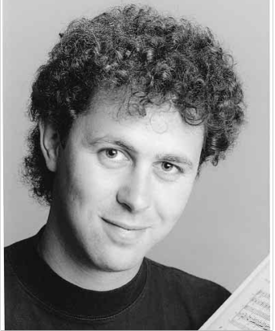

Jonathan Tilbrook
Completed in 1961 and dedicated to the memory of Lenin, the symphony is a dramatic portrayal of the Russian Revolution. Each movement has a subtitle
Ñthe third is named Aurora after the cruiser which gave the signal to begin the October Revolution by firing a shot through the windows of the Winter Palace.
Exhilarating
The 12th symphony has been described as ShostakovichÕs most directly ÔpublicÕ music. The mood of the music varies from quiet contemplation to exhilarating brazen power, but the atmosphere throughout the work clearly demonstrates that the composer has something important to say.
University Philharmonia will also play Nielsen Pan and Syrinx and Sibelius Karelia Suite. The concert begins at 7.30pm and tickets are priced £6 (£4 concessions). Tickets may be booked by contacting
Concerts Secretary Joyce En•er (ext 14764), the Angear Visitors Centre (ext 15791) or Classical CD in the Lace Hall, High Pavement, Nottingham, tel (0115) 948
3832.
concert date remains unchanged, as Sunday December 7, and tickets will now all be sold at the cheaper price of £7 (£5 concessions). Tickets already purchased will be valid for the new venue. If you have bought tickets at the higher price of £10 (£7 concessions), please
contact Joyce En•er on ext 14764.
T
ickets for concerts in the Djanogly Recital Hall have been on sale at Classical CD in the Lace Hall for
some time now, but this season sees the launch
of an exciting new development in the recital hallÕs relationship with NottinghamÕs leading classical music retailer.
DUET at the Djanogly Recital Hall and Classical CD is a special promotion which combines tickets for recital hall concerts with recordings which feature music or artists included in the season. These recordings are all
on sale at Classical CD and, if you purchase tickets for any Djanogly Recital Hall concert at the same time as your CDs, you will receive a discount of 10% on the price of the recordings.
Contact Liz OÕNeill (ext 15797) or Classical CD in the Lace Hall, tel (0115) 948 3832.

10

